MODULE-1
COMPUTER ORGANISATION

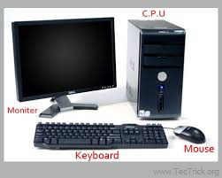
INTRODUCTION TO COMPUTER
Def1: “A computer is a machine that can be instructed to
carry out sequences of arithmetic or logical operations
automatically via computer programming.”
According to Wikipedia.

Def2: A computer is a machine or device that performs processes, calculations and operations based on instructions provided by a software or hardware program. It is designed to execute applications and provides a variety of solutions by combining integrated hardware and software components.
Def3: computer is an electronic device, which stores data and processes information based upon the instructions provided by the user and generates the desired output. A computer is a device that computes or calculates numbers, however, does more than that.
Def4: A computer is a programmable electronic device that accepts raw data as input and processes it with a set of instructions (a program) to produce the result as output.
The term "computer" is derived from the Latin word "computare" which means to calculate.
A computer is designed to execute applications and provides a variety of solutions through integrated hardware and software components. It works with the help of programs and represents the decimal numbers through a string of binary digits.
EVOLUTION OF COMPUTERS
History of Computers
In 1640s, Computer term was first used as "one who calculates." From 1897, term changed and got a new computer meaning "Calculating machine". From 1945 the term indicates as "programmable digital electronic computer".
It is consider that Analytical Engine was the first computer which was invented by Charles Babbage in 1837. It used punch cards as read-only memory. Charles Babbage is also known as the father of the computer.
The first counting device was used by the primitive people. They used sticks, stones and bones as counting tools. As human mind and technology improved with time more computing devices were developed. Some of the popular computing devices starting with the first to recent ones are described below;

Abacus
The history of computer begins with the birth of abacus which is believed to be the first computer. It is said that Chinese invented Abacus around 4,000 years ago.
It was a wooden rack which has metal rods with beads mounted on them. The beads were moved by the abacus operator according to some rules to perform arithmetic calculations. Abacus is still used in some countries like China, Russia and Japan. An image of this tool is shown below;
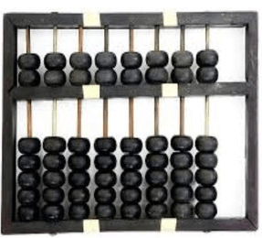

Napier's Bones
It was a manually-operated calculating device which was invented by John Napier (1550-1617) of Merchiston. In this calculating tool, he used 9 different ivory strips or bones marked with numbers to multiply and divide. So, the tool became known as "Napier's Bones. It was also the first machine to use the decimal point.
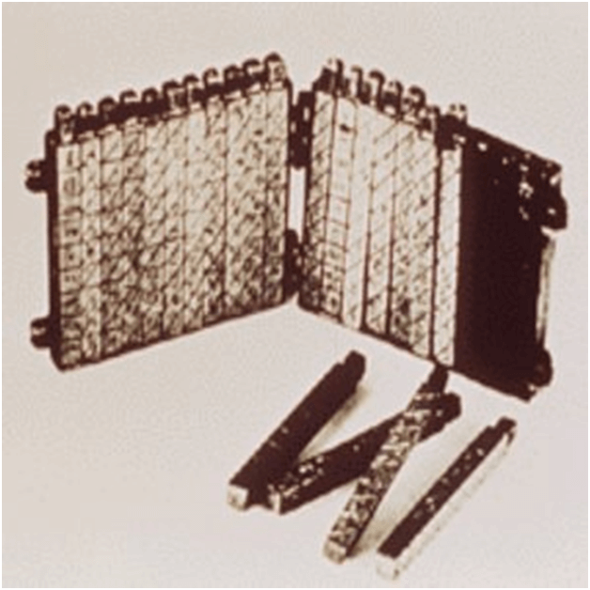

Pascaline
Pascaline is also known as Arithmetic Machine or Adding Machine. It was invented between 1642 and 1644 by a French mathematician-philosopher Biaise Pascal. It is believed that it was the first mechanical and automatic calculator.
Pascal invented this machine to help his father, a tax accountant. It could only perform addition and subtraction. It was a wooden box with a series of gears and wheels. When a wheel is rotated one revolution, it rotates the neighboring wheel. A series of windows is given on the top of the wheels to read the totals. An image of this tool is shown below;
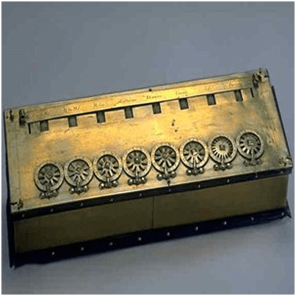

Stepped Reckoner or Leibnitz wheel
It was developed by a German mathematician-philosopher Gottfried Wilhelm Leibnitz in 1673. He improved Pascal's invention to develop this machine. It was a digital mechanical calculator which was called the stepped reckoner as instead of gears it was made of fluted drums. See the following image;
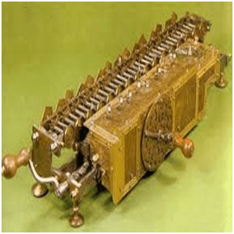

Difference Engine
In the early 1820s, it was designed by Charles Babbage who is known as "Father of Modern Computer". It was a mechanical computer which could perform simple calculations. It was a steam driven calculating machine designed to solve tables of numbers like logarithm tables.
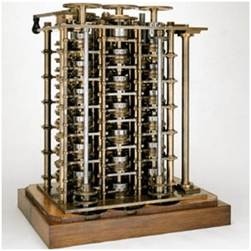

Analytical Engine
This calculating machine was also developed by Charles Babbage in 1830. It was a mechanical computer that used punch-cards as input. It was capable of solving any mathematical problem and storing information as a permanent memory.
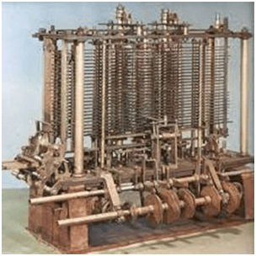

Tabulating Machine
It was invented in 1890, by Herman Hollerith, an American statistician. It was a mechanical tabulator based on punch cards. It could tabulate statistics and record or sort data or information. This machine was used in the 1890 U.S. Census. Hollerith also started the Hollerith?s Tabulating Machine Company which later became International Business Machine (IBM) in 1924.
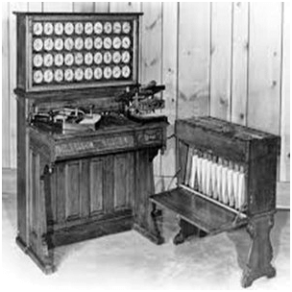

Differential Analyzer
It was the first electronic computer introduced in the United States in 1930. It was an analog device invented by Vannevar Bush. This machine has vacuum tubes to switch electrical signals to perform calculations. It could do 25 calculations in few minutes.
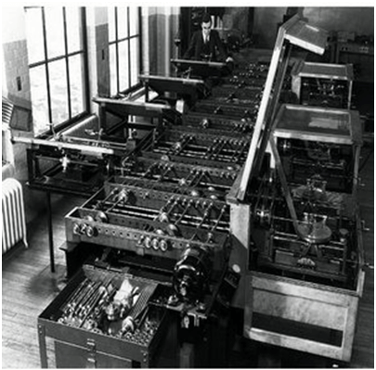

Mark I
The next major changes in the history of computer began in 1937 when Howard Aiken planned to develop a machine that could perform calculations involving large numbers. In 1944, Mark I computer was built as a partnership between IBM and Harvard. It was the first programmable digital computer.

COMPUTER GENERATIONS

First Generation
- The period 1940 to 1956, roughly considered as the First Generation of Computer.
- The first generation computers were developed by using vacuum tube or thermionic valve machine.
- The input of this system was based on punched cards and paper tape; however, the output was displayed on printouts.
- The first generation computers worked on binary-coded concept (i.e., language of 0-1). Examples: ENIAC, EDVAC, etc.
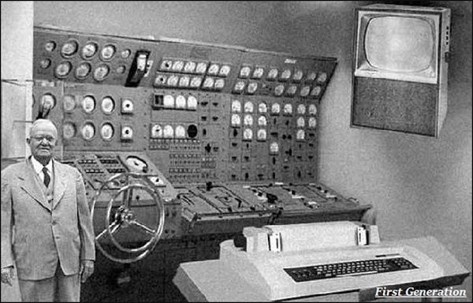

Second Generation
- The period 1956 to 1963 is roughly considered as the period of Second Generation of Computers.
- The second generation computers were developed by using transistor technology.
- In comparison to the first generation, the size of second generation was smaller.
- In comparison to computers of the first generation, the computing time taken by the computers of the second generation was lesser.
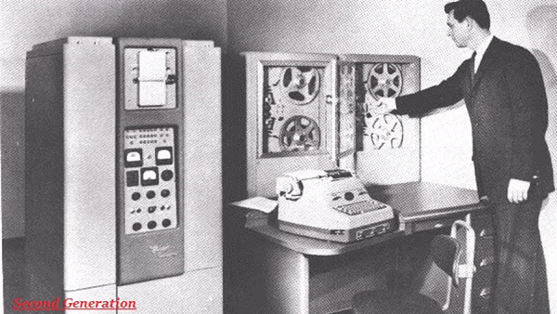

Third Generation
- The period 1963 to 1971 is roughly considered as the period of Third Generation of computers.
- The third generation computers were developed by using the Integrated Circuit (IC) technology.
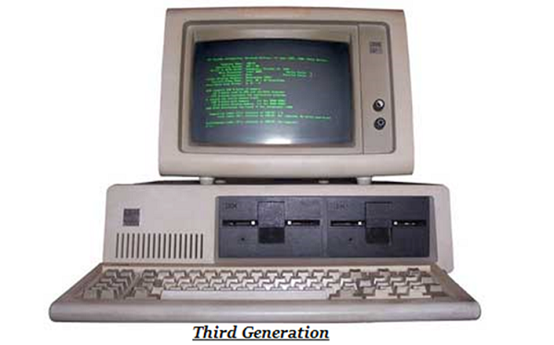
- In comparison to the computers of the second generation, the size of the computers of the third generation was smaller.
- In comparison to the computers of the second generation, the computing time taken by the computers of the third generation was lesser.
- The third generation computer consumed less power and also generated less heat.
- The maintenance cost of the computers in the third generation was also low.
- The computer system of the computers of the third generation was easier for commercial use.

Fourth Generation
- The period 1972 to 2010 is roughly considered as the fourth generation of computers.
- The fourth generation computers were developed by using microprocessor technology.
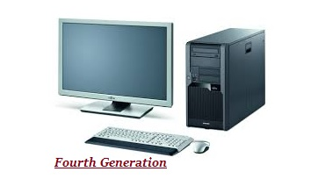
- By coming to fourth generation, computer became very small in size, it became portable.
- The machine of fourth generation started generating very low amount of heat.
- It is much faster and accuracy became more reliable.
- The production cost reduced to very low in comparison to the previous generation.
- It became available for the common people as well.

Fifth Generation
- The period 2010 to till date and beyond, roughly considered as the period of fifth generation of computers.
- By the time, the computer generation was being categorized on the basis of hardware only, but the fifth generation technology also included software.
- The computers of the fifth generation had high capability and large memory capacity.
- Working with computers of this generation was fast and multiple tasks could be performed simultaneously.
- Some of the popular advanced technologies of the fifth generation include Artificial intelligence, Quantum computation, Nanotechnology, Parallel processing, etc.
CLASSIFICATION OF COMPUTERS
- As you know about the name of a computer but it is well to know about the different types of computer. A computer is classified on the base of power, function, and purpose. A computer is an electronic machine that accepts raw data as input, process it according to the instructions, and calculate results/information to the user according to the given instruction. It is not a human but it is a machine for doing some operational. A computer can store information and the user can retrieve it again and again.
- Although a computer can help you to perform complex jobs and solve complicated problems, therefore it is generally classified or categorized as follows.
Different Types of Computer Based on Function and Operation:
- Analog
- Digital
- Hybrid
Analog Computer:
- A computer which is used to measure analog / physical quantity data. Analog means variable and physical quantity may always continue their changes.
- They work by measuring voltage and current. Rather than process of counting.
- They work on by supply of continuous electrical signal and display output continuously.
- They are not general purpose computer.
- Such types of computers accept input in analog form and provide results in analog form. It measures physical quantities like distance, velocity, acceleration, and temperature, e.g. speedometer of care, temperature, watch and voltmeter.
- Now a day analog computer is using for Engineering and Scientific works. In Oil Refinery it measures flow and temperature of the oil. They are also used in Papermaking and the Chemical Industry.
- The output of the analog computer is generally in the form of reading. These computers are used where data can be measured directly from the measuring device.
- Now Analog Computer has been updated to Digital Computers. For example, Analog watch to Digital Watch, Analog weight Balance to Digital Balance and Analog Thermometer to Digital Thermometer, etc.
Digital Computers:
- Those Computers which accepts data in a digital form and provide us information in the same format. It measures digital quantity data and works based on binary digits i.e. 0&1.
- The result of a Digital Computer is more accurate, precise and reliable than Analog Computer. It can process faster than the Analog Computer. Analog Computer has a small memory while Digital Computer has high memory and storage power.
- Accounting machine and Calculator are common examples of a Digital Computer.

Hybrid Computers:
- Those Computers which accepts data in digital form and provide results/ information in analog form and vice versa”.
- Hybrid Computers have the characteristics of both Analog & Digital Computers and measures both analog and digital quantities. Hybrid Computer has a process with the speed of analog and precision of a digital computer. They are used for a special purpose and are designed to perform special task e.g. ECG machine.
- Hybrid Computers are also used in the Air Defense System, and in laboratories for the preparation of medicines.
- Different Types of Computer Based on Power and Size:
- Supercomputer
- Mainframe
- Minicomputer
- Personal Computer or Microcomputer
Supercomputer:
- A supercomputer is the most powerful multi-user and fastest computer in the world. It calculates trillion million instructions per second up to 14 accurate decimal places. Therefore, it is called “Number Cruncher”. Multi CPUs are working together on this computer.
- It work on the principle of parallel processing technique which implement multiple processor to work in parallel way.
- It is designed to maximize the processing of floating point instruction.
- Speed is measured in GFLOPS (Giga Floating Point Operation Per Second).
- It is very expensive with normal costs of several million dollars. It is made for general purpose to solve the problems of Scientists & Engineers and is referred to as “FORTRAN ENGINES” means FORmula TRANslation because FORTRAN language is commonly used by scientists and engineers.
- A supercomputer is considered to be the main tool for the reproduction of nuclear weapons denotation, aerodynamic flows, and global weather patterns.
- Examples: JAGUAR, NEBULAE, IBM’s ROADRUNNER, KRAKEN, JUGENE, PLEIADES, TIANHE-1, Cray-I, Cray-II, CYBER205.
Advantages:
• Solve bigger problems
• Run more problems in shorter time
• May save money
• Allows for virtual testing
• Can be used for R&D
Disadvantages:
• Can be expensive
• Takes up a lot of space
• May only be good for specific applications
• Does not replace physical testing
• Requires trained staff
Mainframe Computer:
- Mainframe Computer is an expensive and a multi-user / multiprocessing computer capable of supporting more than hundreds or thousands of users at the same time. These computers have large size and memory and more powerful than Minicomputer. These computers have high-speed data processing power and can process over millions of arithmetic expressions per second.
- A mainframe computer is expensive and is used by large organizations or industries for significant jobs and data processing. For computerization of a huge business, Universities, Banks, Scientific Laboratories, National & International Markets, etc. it is usually filled with a large room because many peripheral, input, output devices can be attached to it.
- The Mainframe Operation System can support multiprogramming, time-sharing and virtual memory; therefore it is used as Server in a network with many workstations. Many of the terminals can be attached to a Mainframe computer to run different programs.
Advantages -
- Fast I/O operations
- Highly reliable and stable
- High integrity and fault tolerance
- Long uptime (some up to a decade)
- Less error-prone than other computers
- Hot-swap system capacity without system disruption
- Better virtualization than other computers
- Best computer for transaction processing
- Can store and manage large volumes of data
- Supports files in the terabyte range
Disadvantages -
- More expensive than other computers
- Require a cool environment
- Consumes large amounts of energy, but less than supercomputers
- Less processing speed than a supercomputer
Uses -
- Processing large quantities of data
- Transaction processing
- Bulk data processing
- Applications that must not experience down-time
- Database storage and processing
Minicomputer:
- A Minicomputer is a multi-user / multiprocessing computer capable to handle 10 to 200 users simultaneously. These types of computers have a medium size, small memory and more powerful and expensive than Microcomputer. Minicomputer contains one or more processors, support multiprocessing and tasking. They are smaller than Supercomputer and Mainframe computer, but more powerful than personal computers and workstations. Multiple Input & Output devices can be attached to them and used in Networking.
- It is used for computerized the data, scientific research, data collection, industrial process control, and small business application. Time-sharing, batch processing, and online processing are available on it.
Example: PRIME9755, VAX8650, IBM SYSTEM36
Advantages -
- Faster than microcomputers
- Less expensive than mainframes
Disadvantages -
- More expensive than microcomputers
- Not as powerful as a mainframe
- Uses -
- Obsolete
Personal Computer or Microcomputer:
- It is a single-user computer based on microprocessor/microchip inside. It is designed for one person, therefore, it is called a personal computer. These Computers are small in size, small in memory, and less expensive. Many input and output devices can be attached to it. The microcomputer can also attach with Mainframe Computer through a network. It is generally used in home, offices or any working place for web surfing, sending an email, type documents, database, photo editing and entertainment like playing music or games. It is further classified into the following categories.
Advantages -
- Publicly accessible to individuals/citizens
- Relatively inexpensive
- Small and typically easily portable
Disadvantages -
- Less powerful than other computer types
- Less reliable than other computers
- More error-prone than other computers
- Uses -
- Education
- Gaming
- General networking
- General residential and commercial computing
Different Types of Computer Based on Purposes and+ Uses:
- Special Purpose
- General Purpose
- Special Purpose Computers:
- Types of computer which has been manufactured for specific tasks are called Special Purpose Computer. These computers are also known as “Dedicated Computers” because these are designed for special jobs. In other words, they are designed to handle specific problems, e.g. control of traffic lights and in Defense System. A set of instruction or programs is fed to them. As they perform only one type of job so they are very fast.

- General Purpose Computers:
- Types of computers that can perform all types of jobs and can run multiple programs are called General Purpose Computers.
- These computers can perform a variety of jobs, e.g. documentation, accounting, playing of games, making of graphics and doing of arithmetical operations. General Purpose Computers are versatile, but they are slow in processing and less efficient as compared to Dedicated Computers.

BASIC ORGANISATION OF COMPUTERS

Block diagram of Computer

What is the main concept for building block diagram of a computer:
A computer mainly does the below things, the block diagram of a computer is created by conceding the things.
- Firstly, the input units of a computer accepts the data and information
- Secondly, the computer follows the instruction and fulfill the desires of the users
- Thirdly, after justifying the needs of the users, it shows the results
- Fourthly, The results are displayed on the output devices
- Finally, If the users want it can save the data for future purposes

Von-Neumann Model
Von-Neumann proposed his computer architecture design in 1945 which was later known as Von-Neumann Architecture. It consisted of a Control Unit, Arithmetic, and Logical Memory Unit (ALU), Registers and Inputs/Outputs.
Von Neumann architecture is based on the stored-program computer concept, where instruction data and program data are stored in the same memory. This design is still used in most computers produced today.

A Von Neumann-based computer:
- Uses a single processor
- Uses one memory for both instructions and data.
- Executes programs following the fetch-decode-execute cycle
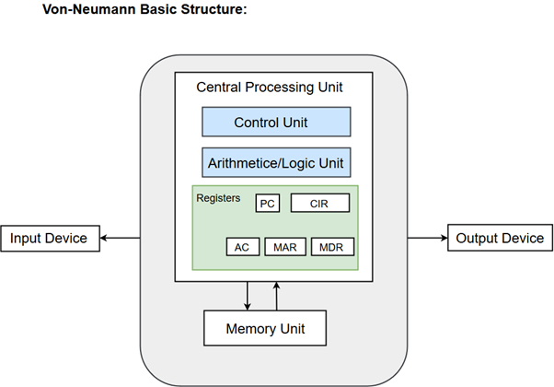

Components of Von-Neumann Model:
- Central Processing Unit
- Buses
- Memory Unit

Central Processing Unit
The part of the Computer that performs the bulk of data processing operations is called the Central Processing Unit and is referred to as the CPU.
The Central Processing Unit can also be defined as an electric circuit responsible for executing the instructions of a computer program.
The CPU performs a variety of functions dictated by the type of instructions that are incorporated in the computer.
The major components of CPU are Arithmetic and Logic Unit (ALU), Control Unit (CU) and a variety of registers.

Arithmetic and Logic Unit (ALU)
The Arithmetic and Logic Unit (ALU) performs the required micro-operations for executing the instructions. In simple words, ALU allows arithmetic (add, subtract, etc.) and logic (AND, OR, NOT, etc.) operations to be carried out.

Control Unit
The Control Unit of a computer system controls the operations of components like ALU, memory and input/output devices.
The Control Unit consists of a program counter that contains the address of the instructions to be fetched and an instruction register into which instructions are fetched from memory for execution.

Registers
Registers refer to high-speed storage areas in the CPU. The data processed by the CPU are fetched from the registers.
Following is the list of registers that plays a crucial role in data processing.
Registers | Description
MAR (Memory Address Register) | This register holds the memory location of the data that needs to be accessed.
MDR (Memory Data Register) | This register holds the data that is being transferred to or from memory.
AC (Accumulator) | This register holds the intermediate arithmetic and logic results.
PC (Program Counter) | This register contains the address of the next instruction to be executed.
CIR (Current Instruction Register) | This register contains the current instruction during processing.

Buses
Buses are the means by which information is shared between the registers in a multiple-register configuration system.
A bus structure consists of a set of common lines, one for each bit of a register, through which binary information is transferred one at a time. Control signals determine which register is selected by the bus during each particular register transfer.
Von-Neumann Architecture comprised of three major bus systems for data transfer.
Bus | Description
Address Bus | Address Bus carries the address of data (but not the data) between the processor and the memory.
Data Bus | Data Bus carries data between the processor, the memory unit and the input/output devices.
Control Bus | Control Bus carries signals/commands from the CPU.

Memory Unit
A memory unit is a collection of storage cells together with associated circuits needed to transfer information in and out of the storage. The memory stores binary information in groups of bits called words. The internal structure of a memory unit is specified by the number of words it contains and the number of bits in each word.
Two major types of memories are used in computer systems:
- RAM (Random Access Memory)
- ROM (Read-Only Memory)
Being a modern-day kid you must have used, seen, or read about computers. This is because they are an integral part of our everyday existence. Be it school, banks, shops, railway stations, hospital or your own home, computers are present everywhere, making our work easier and faster for us. As they are such integral parts of our lives, we must know what they are and how they function. Let us start with defining the term computer formally.
The literal meaning of computer is a device that can calculate. However, modern computers can do a lot more than calculate. Computer is an electronic device that receives input, stores or processes the input as per user instructions and provides output in desired format.

INPUT-PROCESS-OUTPUT MODEL
Computer input is called data and the output obtained after processing it, based on user’s instructions is called information. Raw facts and figures which can be processed using arithmetic and logical operations to obtain information are called data.
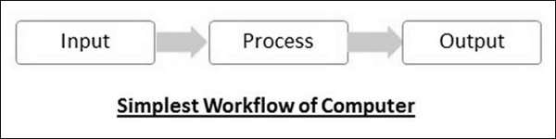
The processes that can be applied to data are of two types −
- Arithmetic operations − Examples include calculations like addition, subtraction, differentials, square root, etc.
- Logical operations − Examples include comparison operations like greater than, less than, equal to, opposite, etc.
The corresponding figure for an actual computer looks something like this −
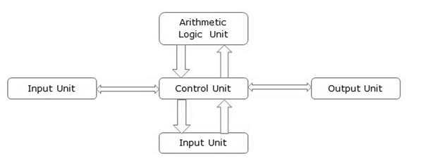
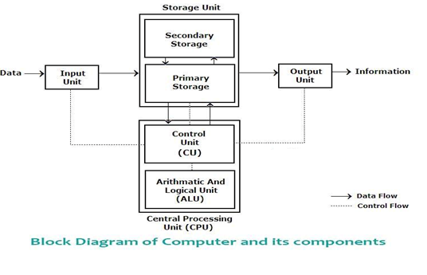
The basic parts of a computer are as follows −

01: Input Unit

Input: This is the process of entering data and programs in to the computer system. You should know that computer is an electronic machine like any other machine which takes as inputs raw data and performs some processing giving out processed data. Therefore, the input unit takes data from us to the computer in an organized manner for processing.

02: Processing Unit

The CPU consists of two main unit including Control Unit and Arithmetic and Logic Unit..

(a) Control Unit:

In the CPU, Control Unit works for receiving the data from the input unit. At the same time, it performs to store the data in the selected place. It finishes the work by following the instructions of Arithmetic logic unit (ALU). On the other hand, it can control the flows of the data.

In general, Control Unit can’t do actual functional work, it takes simple instructions and performs to do it from the input unit.

(b) Arithmetic and Logic Unit:

The name tells itself it works to perform the arithmetic and logical work in the computer. That means if you want to calculate any terms, it will be performed on the Arithmetic logic unit (ALU). Arithmetic and logic unit do the work of addition, subtraction, multiplication, division, AND, OR, NOT, Exclusive OR etc.

Simply, all the actual execution of a computer are performed here according to the instructions. On the other hand, all types of simple or complicated calculations and comparisons are done in the Arithmetic logic unit (ALU).

03: Storage Unit

The primary purposes of the storage unit are storing the data on the computer. It has no other works.There are mostly two types of the popular storage unit on the computer including primary storage and secondary storage.

(a) Primary Storage (Main Memory):

This type of memories is not long lasting. That means, when you will switch off the computer, it will lose all the memory.Generally, RAM (Random Access Memory) is the types of primary memory. It saves the instructions or data on the main memory chip’s circuitry which helps to work fastly of the CPU. In all the computer you will find limited memory for primary storage because it is very costly.

(b) Secondary Storage (Auxiliary Memory):

It is the supportive memory of the main memory. That means, it stores all the software, data or OS of the computer, but can’t function directly. Secondary memory helps to perform the work of main memory. The data on the secondary memory is non-volatile. That means it will not be lost after switching off the computer.

04: Output Unit

This is the process of producing results from the data for getting useful information. Similarly the output produced by the computer after processing must also be kept somewhere inside the computer before being given to you in human readable form. Again the output is also stored inside the computer for further processing.

Control unit, arithmetic logic unit and memory are together called the central processing unit or CPU. Computer devices like keyboard, mouse, printer, etc. that we can see and touch are the hardware components of a computer. The set of instructions or programs that make the computer function using these hardware parts are called software. We cannot see or touch software. Both hardware and software are necessary for working of a computer.
Von Neumann bottleneck –
Whatever we do to enhance performance, we cannot get away from the fact that instructions can only be done one at a time and can only be carried out sequentially. Both of these factors hold back the competence of the CPU. This is commonly referred to as the ‘Von Neumann bottleneck’. We can provide a Von Neumann processor with more cache, more RAM, or faster components but if original gains are to be made in CPU performance then an influential inspection needs to take place of CPU configuration.
This architecture is very important and is used in our PCs and even in Super Computers.

CHARACTERISTICS OF COMPUTER
To understand why computers are such an important part of our lives, let us look at some of its characteristics –
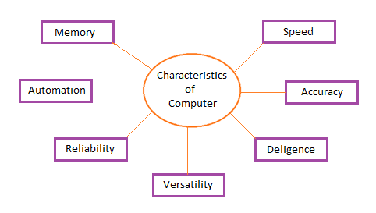
No IQ
Speed − Computer can work very fast. It takes only few seconds for calculations that we take hours to complete.
Computer can perform 3-4 millions (1,000,000) of instructions and even more per second. Therefore, we determine the speed of the computer in terms of microsecond(10^6 part of a second) or nanosecond(10^9 part of A Second).
2 gigahertz to 4 gigahertz is the speed range of computer device.
Accuracy − Computers exhibit a very high degree of accuracy. Errors that may occur are usually due to inaccurate data, wrong instructions or bug in chips – all human errors.
The Errors we received while using personal computer are generally called as “Human Errors” or the errors of programmers who writes program for better computer functions.
GIGO (Garbage In Garbage Out) is a well-known term used for computer accuracy, if the input is wrong the output will also be wrong .
Reliability − Computers can carry out same type of work repeatedly without throwing up errors due to tiredness or boredom, which are very common among humans.
Versatility − The computer system is very versatile machine. The most wonderful feature of the activities of different types from simple calculation to the complex scientific operations and computations and is also capable of preparing the examination marks sheets, bills, letters, documents, and also the design and modelling of navigating missiles and satellites.
Storage Capacity − The Computer has an in-built memory where it can store a large amount of data. Also, data is safe from normal wear and tear associated with paper. We can also store data in secondary storage devices such as floppies, which can be kept outside your computer and can be carried to other computers.
Memory:-This is also one of the most essential characteristics of computer these days they can store or save almost any volume of data due to its high storage capabilities.
Once the data or instruction saved to the computer memory it remains in the memory, until and unless someone deletes.
Users can recall or retrieve the data anytime, at any location they require, as the human being tends to forget small information given to them, but these machines stores all the information was given to them permanently.
These machines can store the data as long as user’s desire. The measurement of memory are MEGABYTES (MB), GIGABYTES (GB) And TERABYTES (TB).Hard disk and pen drives are examples of memory.
Diligence: - A computer is free from tiredness, lack of concentration, fatigue, etc. It can work for hours without creating any error.
If millions of calculations are to be performed, a computer will perform every calculation with the same accuracy. Due to this capability it overpowers human being in routine type of work.
No IQ: - Computer is a dumb machine and it cannot do any work without instruction from the user. It performs the instructions at tremendous speed and with accuracy.
It is we to decide what we want to do and in what sequence. So a computer cannot take its own decision as we can.
PC has errors only when an input is wrong or incorrect, the Computer scientists are working on AI (Artificial Intelligence) which will make them so powerful and accurate that they will make their own decision, and logic when giving some instruction.
This type of computer will have unbelievable characteristics which will change the entire Generations of computer systems.
Automation:-The word automation is conjoint with the computer for a particular task, the computer does not fully depend on the user, but it precedes the task in forward direction automatically till its completion.
Computers can be easily programmed to perform a series of task according to the requirements. The computer automatically executes these instructions sequentially, if any error occurs, it produces the appropriate error message.

COMPUTER MEMORY AND CLASSIFICATION OF MEMORY
The computer memory holds the data and instructions needed to process raw data and produce output. The computer memory is divided into large number of small parts known as cells. Each cell has a unique address which varies from 0 to memory size minus one.
Computer memory is classified in the below hierarchy.
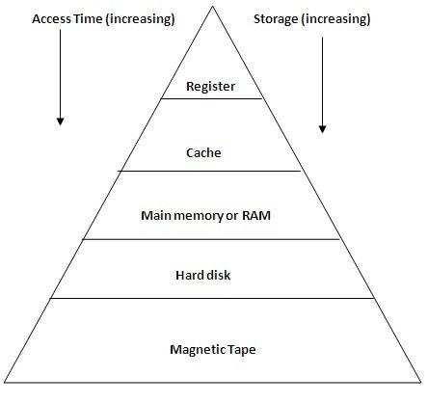

1 . Internal register is for holding the temporary results and variables. Accessing data from these registers is the fastest way of accessing memory.
2. Cache is used by the CPU for memory which is being accessed over and over again. Instead of pulling it every time from the main memory, it is put in cache for fast access. It is also a smaller memory, however, larger than internal register.
Cache is further classified to L1, L2 and L3:
a) L1 cache: It is accessed without any delay.
b) L2 cache: It takes more clock cycles to access than L1 cache.
c) L3 cache: It takes more clock cycles to access than L2 cache.
3) Main memory or RAM (Random Access Memory): It is a type of the computer memory and is a hardware component. It can be increased provided the operating system can handle it.
4) Hard disk: A hard disk is a hardware component in a computer. Data is kept permanently in this memory. Memory from hard disk is not directly accessed by the CPU, hence it is slower. As compared with RAM, hard disk is cheaper per bit.
5) Magnetic tape: Magnetic tape memory is usually used for backing up large data. When the system needs to access a tape, it is first mounted to access the data. When the data is accessed, it is then unmounted. The memory access time is slower in magnetic tape and it usually takes few minutes to access a tape.

Computer memory is of two types: Volatile (RAM) and Non-volatile (ROM). The secondary memory (hard disk) is referred as storage not memory.
But, if we categorize memory on behalf of space or location, it is of four types:
- Register memory
- Cache memory
- Primary memory
- Secondary memory

REGISTER MEMORY
Register memory is the smallest and fastest memory in a computer. It is not a part of the main memory and is located in the CPU in the form of registers, which are the smallest data holding elements. A register temporarily holds frequently used data, instructions, and memory address that are to be used by CPU. They hold instructions that are currently processed by the CPU. All data is required to pass through registers before it can be processed. So, they are used by CPU to process the data entered by the users.
Registers hold a small amount of data around 32 bits to 64 bits. The speed of a CPU depends on the number and size (no. of bits) of registers that are built into the CPU. Registers can be of different types based on their uses. Some of the widely used Registers include Accumulator or AC, Data Register or DR, the Address Register or AR, Program Counter (PC), I/O Address Register, and more.

Types and Functions of Computer Registers:
- Data Register: It is a 16-bit register, which is used to store operands (variables) to be operated by the processor. It temporarily stores data, which is being transmitted to or received from a peripheral device.
- Program Counter (PC): It holds the address of the memory location of the next instruction, which is to be fetched after the current instruction is completed. So, it is used to maintain the path of execution of the different programs and thus executes the programs one by one, when the previous instruction gets completed.
- Instructor Register: It is a 16-bit register. It stores the instruction which is fetched from the main memory. So, it is used to hold instruction codes, which are to be executed. The Control Unit takes instruction from Instructor Register, then decodes and executes it.
- Accumulator Register: It is a 16-bit register, which is used to store the results produced by the system. For example, the results generated by CPU after the processing are stored in the AC register.
- Address Register: It is a 12-bit register that stores the address of a memory location where instructions or data is stored in the memory.
- I/O Address Register: Its job is to specify the address of a particular I/O device.
- I/O Buffer Register: Its job is to exchange the data between an I/O module and the CPU.

CACHE MEMORY
Cache memory is a high-speed memory, which is small in size but faster than the main memory (RAM). The CPU can access it more quickly than the primary memory. So, it is used to synchronize with high-speed CPU and to improve its performance.
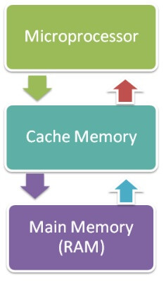
Cache memory can only be accessed by CPU. It can be a reserved part of the main memory or a storage device outside the CPU. It holds the data and programs which are frequently used by the CPU. So, it makes sure that the data is instantly available for CPU whenever the CPU needs this data. In other words, if the CPU finds the required data or instructions in the cache memory, it doesn't need to access the primary memory (RAM). Thus, by acting as a buffer between RAM and CPU, it speeds up the system performance.

Types of Cache Memory:
L1: It is the first level of cache memory, which is called Level 1 cache or L1 cache. In this type of cache memory, a small amount of memory is present inside the CPU itself. If a CPU has four cores (quad core cpu), then each core will have its own level 1 cache. As this memory is present in the CPU, it can work at the same speed as of the CPU. The size of this memory ranges from 2KB to 64 KB. The L1 cache further has two types of caches: Instruction cache, which stores instructions required by the CPU, and the data cache that stores the data required by the CPU.
L2: This cache is known as Level 2 cache or L2 cache. This level 2 cache may be inside the CPU or outside the CPU. All the cores of a CPU can have their own separate level 2 cache, or they can share one L2 cache among themselves. In case it is outside the CPU, it is connected with the CPU with a very high-speed bus. The memory size of this cache is in the range of 256 KB to the 512 KB. In terms of speed, they are slower than the L1 cache.
L3: It is known as Level 3 cache or L3 cache. This cache is not present in all the processors; some high-end processors may have this type of cache. This cache is used to enhance the performance of Level 1 and Level 2 cache. It is located outside the CPU and is shared by all the cores of a CPU. Its memory size ranges from 1 MB to 8 MB. Although it is slower than L1 and L2 cache, it is faster than Random Access Memory (RAM).

How does cache memory work with CPU?
When CPU needs the data, first of all, it looks inside the L1 cache. If it does not find anything in L1, it looks inside the L2 cache. If again, it does not find the data in L2 cache, it looks into the L3 cache. If data is found in the cache memory, then it is known as a cache hit. On the contrary, if data is not found inside the cache, it is called a cache miss.
If data is not available in any of the cache memories, it looks inside the Random Access Memory (RAM). If RAM also does not have the data, then it will get that data from the Hard Disk Drive.
So, when a computer is started for the first time, or an application is opened for the first time, data is not available in cache memory or in RAM. In this case, the CPU gets the data directly from the hard disk drive. Thereafter, when you start your computer or open an application, CPU can get that data from cache memory or RAM.

PRIMARY MEMORY
Primary Memory is of two types: RAM and ROM.

RAM (Volatile Memory)
It is a volatile memory. It means it does not store data or instructions permanently. When you switch on the computer the data and instructions from the hard disk are stored in RAM.
CPU utilizes this data to perform the required tasks. As soon as you shut down the computer the RAM loses all the data.

ROM (Non-volatile Memory)
It is a non-volatile memory. It means it does not lose its data or programs that are written on it at the time of manufacture. So it is a permanent memory that contains all important data and instructions needed to perform important tasks like the boot process.
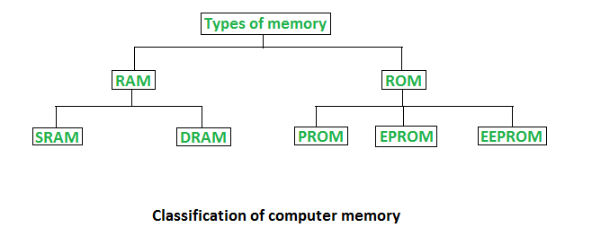

1. Random Access Memory (RAM) –

- It is also called as read write memory or the main memory or the primary memory.
- The programs and data that the CPU requires during execution of a program are stored in this memory.
- It is a volatile memory as the data loses when the power is turned off.
- RAM is further classified into two types- SRAM (Static Random Access Memory) and DRAM (Dynamic Random Access Memory).
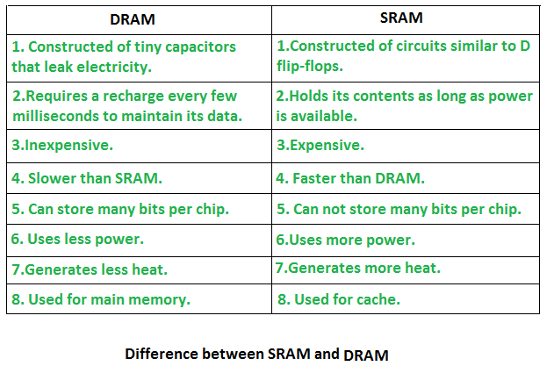

2. Read Only Memory (ROM) –
- Stores crucial information essential to operate the system, like the program essential to boot the computer.
- It is not volatile.
- Always retains its data.
- Used in embedded systems or where the programming needs no change.
- Used in calculators and peripheral devices.
- ROM is further classified into 4 types- ROM, PROM, EPROM, and EEPROM.

Types of Read Only Memory (ROM) –
- PROM (Programmable read-only memory) – It can be programmed by user. Once programmed, the data and instructions in it cannot be changed.
- EPROM (Erasable Programmable read only memory) – It can be reprogrammed. To erase data from it, expose it to ultra violet light. To reprogram it, erase all the previous data.
- EEPROM (Electrically erasable programmable read only memory) – The data can be erased by applying electric field, no need of ultra violet light. We can erase only portions of the chip.

SECONDARY MEMORY
The secondary storage devices which are built into the computer or connected to the computer are known as a secondary memory of the computer. It is also known as external memory or auxiliary storage.
The secondary memory is accessed indirectly via input/output operations. It is non-volatile, so permanently stores the data even when the computer is turned off or until this data is overwritten or deleted. The CPU can't directly access the secondary memory. First, the secondary memory data is transferred to primary memory then the CPU can access it.
Some of the secondary memory or storage devices are described below:

1) Hard Disk:
It is a rigid magnetic disc that is used to store data. It permanently stores data and is located within a drive unit.
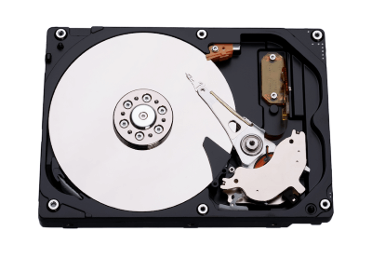
The hard disk is also known as a hard drive. It is a rigid magnetic disc that stores data permanently, as it is a non-volatile storage device. The hard disk is located within a drive unit on the computer's motherboard and comprises one or more platters packed in an air-sealed casing. The data is written on the platters by moving a magnetic head over the platters as they spin. The data stored on a computer's hard drive generally includes the operating system, installed software, and the user's files and programs, including pictures, music, videos, text documents, etc.
Components of Hard Drive:
The main components of a hard drive include a head actuator, read/write actuator arm, read/write head, platter, and spindle. A circuit board, which is called the disk controller or interface board, is present on the back of a hard drive. It allows the hard drive to communicate with the computer.

2) Solid-state Drive:
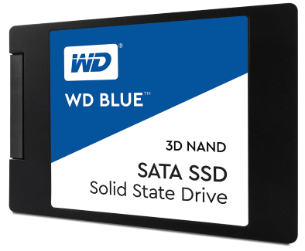
SSD (Solid State Drive) is also a non-volatile storage medium that is used to hold and access data. Unlike a hard drive, it does not have moving components, so it offers many advantages over SSD, such as faster access time, noiseless operation, less power consumption, and more.
As the cost of SSD has come down, it has become an ideal replacement for a standard hard drive in desktop and laptop computers. It is also suitable for notebooks, and tablets that don't require lots of storage.

3) Pen drive:
Pen drive is a compact secondary storage device. It is also known as a USB flash drive, thumb drive or a jump drive. It connects to a computer via a USB port. It is commonly used to store and transfer data between computers. For example, you can write a report using a computer and then copy or transfer it in the pen drive. Later, you can connect this pen drive to a computer to see or edit your report. You can also store your important documents and pictures, music, videos in the pen drive and keep it at a safe place.
Pen drive does not have movable parts; it comprises an integrated circuit memory chip that stores the data. This chip is housed inside a plastic or aluminium casing. The data storage capacity of the pen drive generally ranges from 2 GB to 128 GB. Furthermore, it is a plug and play device as you don't need additional drives, software, or hardware to use it.

4) SD Card:
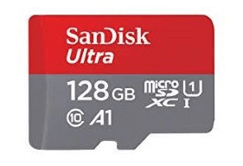
SD Card stands for Secure Digital Card. It is most often used in portable and mobile devices such as smartphones and digital cameras. You can remove it from your device and see the things stored in it using a computer with a card reader.
There are many memory chips inside the SD card that store the data; it does not have moving parts. SD cards are not created equal, so they may differ from each other in terms of speed, physical sizes, and capacity. For example, standard SD cards, mini SD cards, and micro SD cards.

5) Compact Disk (CD):
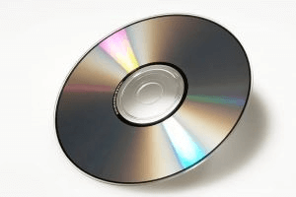
Compact Disk is a portable secondary storage device in the shape of a round medium disk. It is made of polycarbonate plastic. The concept of CD was co-developed by Philips and Sony in 1982. The first CD was created on 17 August 1982 at the workshop of Philips in Germany.
In the beginning, it was used for storing and playing sound recordings, later it was used for various purposes such as for storing documents, audio files, videos, and other data like software programs in a CD.
Physical characteristics of a CD/ Structure of CD:
A standard CD is around 5 inches in diameter and 0.05 inches in thickness. It is made of a clear polycarbonate plastic substrate, a reflective metallic layer, and a clear coating of acrylic plastic. These thin circular layers are attached one on top of another as described below:
- A polycarbonate disc layer at the bottom has the data encoded by creating lands and pits.
- The polycarbonate disc layer is coated with a thin aluminium layer that reflects the laser.
- The reflective aluminium layer is coated with a lacquer layer to prevent oxidation in order to protect the below layers. It is generally spin coated directly on the top of the reflective layer.
- The label print is applied on the lacquer layer, or artwork is screen printed on the top of the disc on the lacquer layer by offset printing or screen printing.

How Does a CD Work?
The data or information is stored or recorded or encoded in CD digitally using a laser beam that etches tiny indentations or bumps on its surface. The bump is called a pit, which represents the number 0. Space, where the bump is not created, is called land, and it represents the number 1. Thus, the data is encoded into a compact disc by creating pits (0) and lands (1). The CD players use laser technology to read the optically recorded data.

6) DVD:
DVD is short for digital versatile disc or digital video disc. It is a type of optical media used for storing optical data. Although it has the same size as a CD, its storage capacity is much more than a CD. So, it is widely used for storing and viewing movies and to distribute software programs as they are too large to fit on a CD. DVD was co-developed by Sony, Panasonic, Philips, and Toshiba in 1995.

Types of DVDs:
DVDs can be divided into three main categories which are as follows:
- DVD-ROM (Read-Only): These types of DVDs come with media already recorded on them, such as movie dvds. As the name suggests, data on these discs cannot be erased or added, so these discs are known as a read-only or non-writable DVD.
- DVD-R (Writable): It allows you to record or write information to the DVD. However, you can write information only once as it becomes a read-only DVD once it is full.
- DVD-RW (Rewritable or Erasable): This type of discs can be erased, written, or recorded multiple times.

Memory Units
Memory units are used to measure and represent data. Some of the commonly used memory units are:
1) Bit: The computer memory units start from bit. A bit is the smallest memory unit to measure data stored in main memory and storage devices. A bit can have only one binary value out of 0 and 1.
2) Byte: It is the fundamental unit to measure data. It contains 8 bits or is equal to 8 bits. Thus a byte can represent 2*8 or 256 values.
3) Kilobyte: A kilobyte contains 1024 bytes.
4) Megabyte: A megabyte contains 1024 kilobytes.
5) Gigabyte: A gigabyte contains 1024 megabyte.
6) Terabyte: A terabyte contains 1024 gigabytes.

