# MODULE-2

# COMPUTER SOFTWARE

# SOFTWARE CONCEPTS

A Computer is an electronic device that can perform various operations of computation at a greater speed than what an ordinary machine or human mind can do. It is driven by many entities including the physical and tangible components that we can touch or feel, called the **Hardware** and programs and commands that drive the hardware, called the **Software**.  
The Software refers to the set of instructions fed in form of programs to govern the computer system and process the hardware components. For example:

* The antivirus that we use to protect our computer system is a type of Software.
* The media players that we use to play multimedia files such as movies, music etc. are Software.
* The Microsoft Office we use to edit the documents is a Software.

Depending on its use and area of implementation, Software’s can be divided into 3 major types:

1. **System Software**
2. **Application Software**
3. **Utility Software**

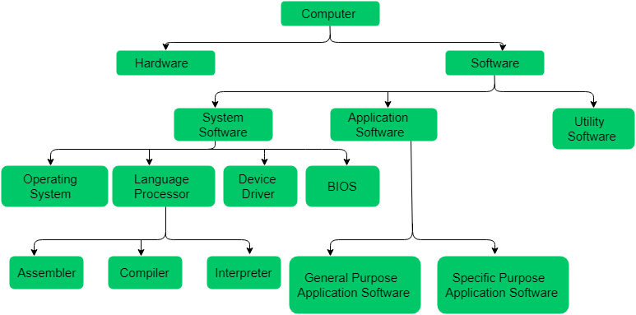

### SYSTEM SOFTWARE

These are the software that directly allows the user to interact with the hardware components of a computer system. As the humans and machines follow different languages, there has to be an interface that will allow the users to interact with the core system, this interface is provided by the software. The system software can be called the main or the alpha software of a computer system as it handles the major portion of running a hardware. This System Software can be further divided into four major types:

1. **The Operating System** – It is the main program that governs and maintains the inter-cooperation of the components of a computer system. For eg., Microsoft Windows, Linux, Mac OS etc.
2. **The Language Processor** – The hardware components present in the computer system does not understand human language. There are three types of languages involved in the world of human-machine interaction:
   * **Machine-Level Language:** The machines only understand the digital signals or the binary codes or the binary language which consist of strings of 0’s and 1’s. These are totally machine dependent language.
   * **Assembly-Level Language:** These are the Low-Level Language(LLL), that forms a correspondence between machine level instruction and general assembly level statements. Assembly language uses a mnemonics to represent each low-level machine instruction or operation-code also called the op-codes. For eg., ADD instruction is used to add two entities, the HALT instruction is used to stop a process etc. It is a machine dependent language and varies from processor to processor.
   * **High-Level Language:** These are the simple English statements, that humans use to program and code as it is easy to read and understand to the human world. For eg., Java, C, C++, Python etc.

The machine level language is very complex to understand and code, therefore the users prefer the High-Level Language or the HLL for coding. These codes need to be converted into the machine language so that the computer can easily understand and work accordingly. This operation is performed by the Language Processor which is made up of further three components:

* + **Assembler:** This language processor is used to convert the assembly language into machine level language.
  + **Compiler:** This language processor is used to convert High-Level Language into machine level language in one go, thus execution time is fast. The error detection is difficult in a compiler. Programming Languages like C, C++ and Scala use compiler.
  + **Interpreter:** This language processor is also used to convert High-Level Language into machine level language line-by-line, thus execution time is slow. Error-detection is easier in an interpreter as it reports as soon as a bug is caught and restarts the process. This consumes unnecessary memory. Programming Languages like Python, Ruby and Java uses an interpreter.

1. **The Device Drivers** – The device drivers and the device programs or the system software that acts as an interface between the various Input-Output device and the users or the operating system. For eg., the Printers, Web cameras come with a driver disk that is needed to be installed into the system to make the device run in the system.
2. **The BIOS** – It stands for Basic Input Output System and is a small firmware, that controls the peripheral or the input-output devices attached to the system. This software is also responsible for starting the OS or initiating the booting process.

### APPLICATION SOFTWARE

These are the basic software used to run to accomplish a particular action and task. These are the dedicated software, dedicated to performing simple and single tasks. For eg., a single software cannot serve to both the reservation system and banking system. These are divided into two types:

1. **The General Purpose Application Software:** These are the types of application software that comes in-built and ready to use, manufactures by some company or someone. For eg.,
   * Microsoft Excel – Used to prepare excel sheets.
   * VLC Media Player – Used to play audio/video files.
   * Adobe Photoshop – Used for designing and animation and many more.
2. **The Specific Purpose Application Software:** These are the type of software that is customizable and mostly used in real-time or business environment. For eg.,
   * Ticket Reservation System
   * Healthcare Management System
   * Hotel Management System
   * Payroll Management System

### UTILITY SOFTWARE

These are the most basic type of software which provides high utility to the user and the system. These perform the basic but daily need tasks. For eg.,

* Antivirus Softwares: These provide protection to the computer system from unwanted malware and viruses. For eg., QuickHeal, McAfee etc.
* Disk Defragmenter Tools: These help the users to analyse the bad sectors of the disk and rearrange the files in a proper order.
* Text-editors: These help the users to take regular notes and create basic text files. For eg., Notepad, Gedit etc.

## PROGRAMMING SOFTWARE:

It is a set or collection of tools that help developers in writing other software or programs. It assists them in creating, debugging, and maintaining software or programs or applications. We can say that these are facilitator software that helps translate programming language such as Java, C++, Python, etc., into machine language code. So, it is not used by end-users. For example, compilers, linkers, debuggers, interpreters, text editors, etc. This software is also called a programming tool or software development tool.

Some examples of programming software include:

* **Eclipse:** It is a java language editor.
* **Coda:** It is a programming language editor for Mac.
* **Notepad++:** It is an open-source editor for windows.
* **Sublime text:** It is a cross-platform code editor for Linux, Mac, and Windows.

**DIFFERENCE BETWEEN HARDWARE AND SOFTWARE:**

**HARDWARE SOFTWARE**

|  |  |
| --- | --- |
| Hardware is a physical parts computer that cause processing of data. | Software is a set of instruction that tells a computer exactly what to do. |
| It is manufactured. | It is developed and engineered. |
| Hardware can not perform any task without software. | software can not be executed without hardware. |
| As Hardware are physical electronic devices, we can see and touch hardware. | We can see and also use the software but can’t actually touch them. |
| It has four main categories: input device, output devices, storage, and internal components. | It is mainly divided into System software, Programming software and Application software. |
| Hardware is not affected by computer viruses. | Software is affected by computer viruses. |
| It can not be transferred from one place to another electrically through network. | But, it can be transferred. |
| If hardware is damaged, it is replaced with new one. | If software is damaged, its backup copy can be reinstalled. |
| Ex: Keyboard, Mouse, Monitor, Printer, CPU, Hard disk, RAM, ROM etc. | Ex: Ms Word, Excel, Power Point, Photoshop, MySQL etc. |

## OVERVIEW OF OPERATING SYSTEM

## DEFINITION OF OS:-

## In the Computer System (comprises of Hardware and software), Hardware can only understand machine code (in the form of 0 and 1) which doesn't make any sense to a naive user.

We need a system which can act as an intermediary and manage all the processes and resources present in the system.

An **Operating System** can be defined as an **interface between user and hardware**. It is responsible for the execution of all the processes, Resource Allocation, CPU management, File Management and many other tasks.

The purpose of an operating system is to provide an environment in which a user can execute programs in convenient and efficient manner.

## STRUCTURE OF A COMPUTER SYSTEM

## A Computer System consists of:

* Users (people who are using the computer)
* Application Programs (Compilers, Databases, Games, Video player, Browsers, etc.)
* System Programs (Shells, Editors, Compilers, etc.)
* Operating System ( A special program which acts as an interface between user and hardware )
* Hardware ( CPU, Disks, Memory, etc)

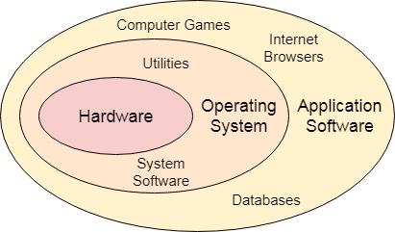

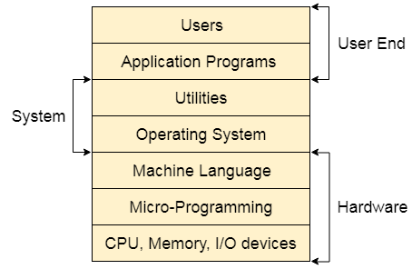

## Objectives of Operating System

An operating system consists of a special program that controls the execution of the application program. The OS acts as an intermediary between applications and hardware components. OS can be thought of as having three objectives. These are:

* **Convenience**: It makes a computer more suitable to use.
* **Efficiency**: It provides the computer system resources with efficiency and in easy to use format.
* **Ability to develop**: It should be built in such a way that it permits the efficient development, testing, and installation of new system functions without interfering with service.

## Functions of Operating System

**Security –**  
The operating system uses password protection to protect user data and similar other techniques. it also prevents unauthorized access to programs and user data.

**Control over system performance –**  
Monitors overall system health to help improve performance. records the response time between service requests and system response to have a complete view of the system health. This can help improve performance by providing important information needed to troubleshoot problems.

**Job accounting –**  
Operating system Keeps track of time and resources used by various tasks and users, this information can be used to track resource usage for a particular user or group of user.

**Error detecting aids –**  
Operating system constantly monitors the system to detect errors and avoid the malfunctioning of computer system.

**Coordination between other software and users –**  
Operating systems also coordinate and assign interpreters, compilers, assemblers and other software to the various users of the computer systems.

**Memory Management –**  
The operating system manages the Primary Memory or Main Memory. Main memory is made up of a large array of bytes or words where each byte or word is assigned a certain address. Main memory is a fast storage and it can be accessed directly by the CPU. For a program to be executed, it should be first loaded in the main memory. An Operating System performs the following activities for memory management:

It keeps tracks of primary memory, i.e., which bytes of memory are used by which user program. The memory addresses that have already been allocated and the memory addresses of the memory that has not yet been used. In multi programming, the OS decides the order in which process are granted access to memory, and for how long. It Allocates the memory to a process when the process requests it and deallocates the memory when the process has terminated or is performing an I/O operation.

**Processor Management –**  
In a multi programming environment, the OS decides the order in which processes have access to the processor, and how much processing time each process has. This function of OS is called process scheduling. An Operating System performs the following activities for processor management.

Keeps tracks of the status of processes. The program which perform this task is known as traffic controller. Allocates the CPU that is processor to a process. De-allocates processor when a process is no more required.

**Device Management –**  
An OS manages device communication via their respective drivers. It performs the following activities for device management. Keeps tracks of all devices connected to system. designates a program responsible for every device known as the Input/Output controller. Decides which process gets access to a certain device and for how long. Allocates devices in an effective and efficient way. Deallocates devices when they are no longer required.

**File Management –**  
A file system is organized into directories for efficient or easy navigation and usage. These directories may contain other directories and other files. An Operating System carries out the following file management activities. It keeps track of where information is stored, user access settings and status of every file and more… These facilities are collectively known as the file system.

Moreover, Operating System also provides certain services to the computer system in one form or the other.  
**The Operating System provides certain services to the users which can be listed in the following manner:**

**Program Execution**: The Operating System is responsible for execution of all types of programs whether it be user programs or system programs. The Operating System utilises various resources available for the efficient running of all types of functionalities.

**Handling Input/Output Operations**: The Operating System is responsible for handling all sort of inputs, i.e, from keyboard, mouse, desktop, etc. The Operating System does all interfacing in the most appropriate manner regrading all kind of Inputs and Outputs.  
For example, there is difference in nature of all types of peripheral devices such as mouse or keyboard, then Operating System is responsible for handling data between them.

**Manipulation of File System**: The Operating System is responsible for making of decisions regarding the storage of all types of data or files, i.e, floppy disk/hard disk/pen drive, etc. The Operating System decides as how should the data should be manipulated and stored.

**Error Detection and Handling**: The Operating System is responsible for detection of any types of error or bugs that can occur while any task. The well secured OS sometimes also acts as countermeasure for preventing any sort of breach to the Computer System from any external source and probably handling them.

**Resource Allocation:** The Operating System ensures the proper use of all the resources available by deciding which resource to be used by whom for how much time. All the decisions are taken by the Operating System.

**Accounting:** The Operating System tracks an account of all the functionalities taking place in the computer system at a time. All the details such as the types of errors occurred are recorded by the Operating System.

**Information and Resource Protection:** The Operating System is responsible for using all the information and resources available on the machine in the most protected way. The Operating System must foil an attempt from any external resource to hamper any sort of data or information.

All these services are ensured by the Operating System for the convenience of the users to make the programming task easier. All different kinds of Operating System more or less provide the same services.

**Following are the major applications of an operating system −**

* An operating system is accountable for the formation and deletion of files and directories.
* An operating system manages the process of deletion, suspension, resumption, and synchronization.
* An operating system manages memory space by allocation and de-allocation.
* An operating system stores, organizes, and names and protects the existing files.
* Further, an operating system manages all the components and devices of the computers system including modems, printers, plotters, etc.
* In case, if any device fails, the operating system detects and notify.
* An operating system protects from destruction as well as from unauthorized use.
* An operating system facilitates the interface to user and hardware.

**TYPES OF OPERATING SYSTEMS**

An [Operating System](https://www.geeksforgeeks.org/operating-system-introduction-operating-system-set-1/) performs all the basic tasks like managing file,process, and memory. Thus operating system acts as manager of all the resources, i.e. **resource manager**. Thus operating system becomes an interface between user and machine.

**1. Batch Operating System –**

This type of operating system does not interact with the computer directly. There is an operator which takes similar jobs having same requirement and group them into batches. It is the responsibility of operator to sort the jobs with similar needs.

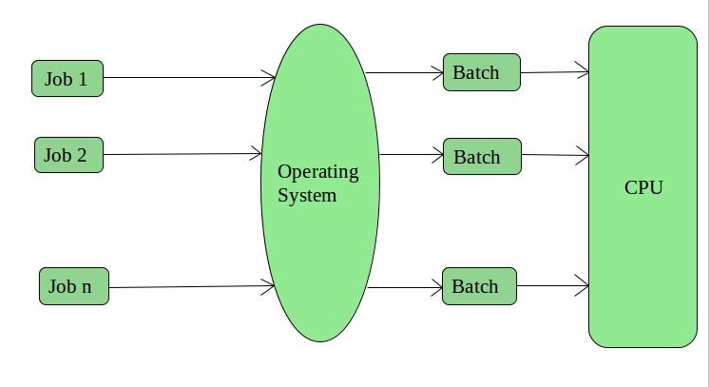

**Advantages of Batch Operating System:**

* It is very difficult to guess or know the time required by any job to complete. Processors of the batch systems know how long the job would be when it is in queue
* Multiple users can share the batch systems
* The idle time for batch system is very less
* It is easy to manage large work repeatedly in batch systems

**Disadvantages of Batch Operating System:**

* The computer operators should be well known with batch systems
* Batch systems are hard to debug
* It is sometime costly
* The other jobs will have to wait for an unknown time if any job fails

**Examples of Batch based Operating System:** Payroll System, Bank Statements etc.

**2. Time-Sharing Operating Systems –**

Each task is given some time to execute, so that all the tasks work smoothly. Each user gets time of CPU as they use single system. These systems are also known as Multitasking Systems. The task can be from single user or from different users also. The time that each task gets to execute is called quantum. After this time interval is over OS switches over to next task.

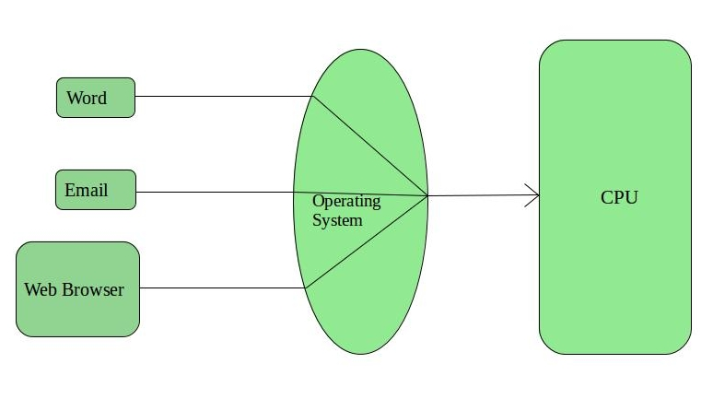

**Advantages of Time-Sharing OS:**

* Each task gets an equal opportunity
* Less chances of duplication of software
* CPU idle time can be reduced

**Disadvantages of Time-Sharing OS:**

* Reliability problem
* One must have to take care of security and integrity of user programs and data
* Data communication problem

**Examples of Time-Sharing OSs are:** Multics, Unix etc.

## 3. Multiprocessor Systems

A Multiprocessor system consists of several processors that share a common physical memory. Multiprocessor system provides higher computing power and speed. In multiprocessor system all processors operate under single operating system. Multiplicity of the processors and how they do act together are transparent to the others.

**Advantages of Multiprocessor Systems**

1. Enhanced performance
2. Execution of several tasks by different processors concurrently, increases the system's throughput without speeding up the execution of a single task.
3. If possible, system divides task into many subtasks and then these subtasks can be executed in parallel in different processors. Thereby speeding up the execution of single tasks.

## 4. Multiprogramming Batch Systems

* In this the operating system picks up and begins to execute one of the jobs from memory.
* Once this job needs an I/O operation operating system switches to another job (CPU and OS always busy).
* Jobs in the memory are always less than the number of jobs on disk(Job Pool).
* If several jobs are ready to run at the same time, then the system chooses which one to run through the process of **CPU Scheduling**.
* In Non-multiprogrammed system, there are moments when CPU sits idle and does not do any work.
* In Multiprogramming system, CPU will never be idle and keeps on processing.

**Time Sharing Systems** are very similar to Multiprogramming batch systems. In fact time sharing systems are an extension of multiprogramming systems.

In Time sharing systems the prime focus is on **minimizing the response time**, while in multiprogramming the prime focus is to maximize the CPU usage.

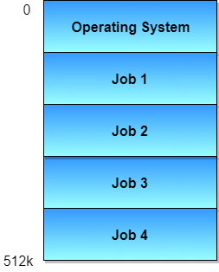

**5. Real-Time Operating System –**

These types of OSs serve the real-time systems. The time interval required to process and respond to inputs is very small. This time interval is called **response time**.

**Real-time systems** are used when there are times requirements are very strict like missile systems, air traffic control systems, robots etc.

**Two types of Real-Time Operating System which are as follows:**

* **Hard Real-Time Systems:**  
  These OSs are meant for the applications where time constraints are very strict and even the shortest possible delay is not acceptable. These systems are built for saving life like automatic parachutes or air bags which are required to be readily available in case of any accident. Virtual memory is almost never found in these systems.
* **Soft Real-Time Systems:**  
  These OSs are for applications where for time-constraint is less strict.

**Advantages of RTOS:**

* **Maximum Consumption:** Maximum utilization of devices and system,thus more output from all the resources
* **Task Shifting:** Time assigned for shifting tasks in these systems are very less. For example in older systems it takes about 10 micro seconds in shifting one task to another and in latest systems it takes 3 micro seconds.
* **Focus on Application:** Focus on running applications and less importance to applications which are in queue.
* **Real time operating system in embedded system:** Since sizes of programs are small, RTOS can also be used in embedded systems like in transport and others.
* **Error Free:** These types of systems are error free.
* **Memory Allocation:** Memory allocation is best managed in these types of systems.

**Disadvantages of RTOS:**

* **Limited Tasks:** Very few tasks run at the same time and their concentration is very less on few applications to avoid errors.
* **Use heavy system resources:** Sometimes the system resources are not so good and they are expensive as well.
* **Complex Algorithms:** The algorithms are very complex and difficult for the designer to write on.
* **Device driver and interrupt signals:** It needs specific device drivers and interrupt signals to response earliest to interrupts.
* **Thread Priority:** It is not good to set thread priority as these systems are very less prone to switching tasks.

**Examples of Real-Time Operating Systems are:** Scientific experiments, medical imaging systems, industrial control systems, weapon systems, robots, air traffic control systems, etc.

Let’s see the difference between DOS and Windows:

## DISK OPERATING SYSTEM

MS-DOS (shorthand for Microsoft Disk Operating System) is a single tasking, single user, non-graphical command line operating system. Originally developed for use with IBM’s earliest line of personal home computers, MS-DOS is one of the most successful operating systems of its kind. As an operating system, DOS is simple, compact, and remarkably robust; especially considering its age. While it may have been surpassed by the newer, and more user friendly, graphical user interface (GUI) operating systems, MS-DOS remains in widespread use by businesses and independent programmers throughout the world.

MS-DOS is one of the oldest and widely used operating system. DOS is a set of computer programs, the major functions of which are file management, allocation of system resources, providing essential features to control hardware devices.

DOS commands can be typed in either upper case or lower case.

## A History of MS-DOS

The origins of MS-DOS can be traced back to two earlier operating systems, CP/M and QDOS. CP/M (AKA Control Program for Microcomputers) was created in the mid 1970s by Gary Kildall of Digital Research. CP/M was an 8-bit operating system, and was one of the first to be widely used in the emerging line of commercial microcomputers. In 1980, Tom Paterson of Seattle Computer Products developed QDOS (Quick and Dirty Operating System) for Intel’s new 16-bit 8086 central processing unit(CPU). QDOS was largely based on CP/M, and it is here that Microsoft entered the picture.

In 1981 Microsoft purchased QDOS from Seattle Computer Products, renaming it MS-DOS 1.0 and offering it to IBM for use in their new personal computers. In a prescient move, Gates retained the licensing for MS-DOS and it would become the most important factor in Microsoft’s move from a simple vendor of computer programming languages to a giant in the computer software industry. The success of MS-DOS directly paralleled the growing popularity of the personal home computer, and remained Microsoft’s most significant source of income even after the firm began to introduce its own GUI in the form of MS-Windows.

### Features of DOS

Following are the significant features of DOS −

* It is a single user system.
* It controls program.
* It is machine independence.
* It manages (computer) files.
* It manages input and output system.
* It manages (computer) memory.
* It provides command processing facilities.
* It operates with Assembler.

### Types of DOS Commands

Following are the major types of DOS Command −

* **Internal Commands** − Commands such as DEL, COPY, TYPE, etc. are the internal commands that remain stored in computer memory.
* Internal commands are more commonly used and important to the operation and use of the Windows operating system. By embedding them in the command.com file, they can be quickly accessed and always available in MS-DOS and to Windows when needed.

## Listing of internal commands

Below are examples of internal commands in MS-DOS and the Windows command line currently listed in the Computer Hope database.

|  |  |  |  |
| --- | --- | --- | --- |
| [Assoc](https://www.computerhope.com/assoc.htm) [Atmadm](https://www.computerhope.com/atmadm.htm) [Break](https://www.computerhope.com/breakhlp.htm) [Call](https://www.computerhope.com/call.htm) [CD](https://www.computerhope.com/cdhlp.htm) [Chdir](https://www.computerhope.com/chdirhlp.htm) [Cls](https://www.computerhope.com/clshlp.htm) [Color](https://www.computerhope.com/color.htm) [Copy](https://www.computerhope.com/copyhlp.htm) [Ctty](https://www.computerhope.com/cttyhlp.htm) [Date](https://www.computerhope.com/datehlp.htm) [Del](https://www.computerhope.com/delhlp.htm) [Dir](https://www.computerhope.com/dirhlp.htm) [Drivparm](https://www.computerhope.com/drivparm.htm) [Echo](https://www.computerhope.com/echohlp.htm) [Endlocal](https://www.computerhope.com/endlocal.htm) [Erase](https://www.computerhope.com/erasehlp.htm) [Exit](https://www.computerhope.com/exithlp.htm) | [For](https://www.computerhope.com/forhlp.htm) [Goto](https://www.computerhope.com/goto.htm) [If](https://www.computerhope.com/if.htm) [LH Loadhigh](https://www.computerhope.com/lhhlp.htm) [Lock](https://www.computerhope.com/lockhlp.htm) [Md Mkdir](https://www.computerhope.com/mdhlp.htm) [Mklink](https://www.computerhope.com/mklink.htm) [Move](https://www.computerhope.com/movehlp.htm) [Path](https://www.computerhope.com/pathhlp.htm) [Pause](https://www.computerhope.com/pausehlp.htm) [Popd](https://www.computerhope.com/popd.htm) [Prompt](https://www.computerhope.com/prompthl.htm) [Pushd](https://www.computerhope.com/pushd.htm) | [Rd](https://www.computerhope.com/rmdirhlp.htm) [Ren Rename](https://www.computerhope.com/renamehl.htm) [Rmdir](https://www.computerhope.com/rmdirhlp.htm) [Set](https://www.computerhope.com/sethlp.htm) [Setlocal](https://www.computerhope.com/setlocal.htm) [Shift](https://www.computerhope.com/shift.htm) [Start](https://www.computerhope.com/starthlp.htm) [Switches](https://www.computerhope.com/switches.htm) [Time](https://www.computerhope.com/timehlp.htm) [Title](https://www.computerhope.com/titlehlp.htm) [Type](https://www.computerhope.com/typehlp.htm) | [Unlock](https://www.computerhope.com/lockhlp.htm) [Ver](https://www.computerhope.com/verhlp.htm) [Verify](https://www.computerhope.com/verifyhl.htm) [Vol](https://www.computerhope.com/volhlp.htm) |

## Where are the internal command files stored?

Internal commands are part of the [shell](https://www.computerhope.com/jargon/s/shell.htm), which could be [command.com or cmd.exe](https://www.computerhope.com/issues/ch000395.htm) (depending on version of MS-DOS or Windows) and are not separate [files](https://www.computerhope.com/jargon/f/file.htm) on the [hard drive](https://www.computerhope.com/jargon/h/harddriv.htm).

## How do you run an internal command?

As long as you can open a command line, you can run any of the internal commands included with your version of MS-DOS or Microsoft Windows.

* **External Commands** − Commands like FORMAT, DISKCOPY, etc. are the external commands and remain stored on the disk.
* External commands are powerful commands and can help fix problems, improve performance, or perform other actions. External commands usually have higher resource requirements than internal commands. Keeping them in separate files, separated from internal commands, helps to reduce the load on Windows. They can also be added to Windows whenever needed by copying the external command's file to the computer.

## Listing of external commands

Below are examples of MS-DOS and Windows command line external commands currently listed on Computer Hope.

|  |  |  |  |
| --- | --- | --- | --- |
| [Append](https://www.computerhope.com/appendhl.htm) [Arp](https://www.computerhope.com/arphlp.htm) [Assign](https://www.computerhope.com/assignhl.htm) [At](https://www.computerhope.com/at.htm) [Attrib](https://www.computerhope.com/attribhl.htm) [Backup](https://www.computerhope.com/backup.htm) [Bcdedit](https://www.computerhope.com/bcdedit.htm) [Bootsect](https://www.computerhope.com/bootsect.htm) [Cacls](https://www.computerhope.com/cacls.htm) [Chcp](https://www.computerhope.com/chcphlp.htm) [Chkdsk](https://www.computerhope.com/chkdskh.htm) [Chkntfs](https://www.computerhope.com/chkntfs.htm) [Choice](https://www.computerhope.com/choicehl.htm) [Cipher](https://www.computerhope.com/cipher.htm) [Clip](https://www.computerhope.com/clip.htm) [Comp](https://www.computerhope.com/comp.htm) [Compact](https://www.computerhope.com/compact.htm) [Convert](https://www.computerhope.com/convert.htm) [Debug](https://www.computerhope.com/debughlp.htm) [Defrag](https://www.computerhope.com/software/defrag.htm) [Delpart](https://www.computerhope.com/jargon/d/delpart.htm) [Deltree](https://www.computerhope.com/deltree.htm) [Diskcomp](https://www.computerhope.com/diskcomp.htm) [Diskcopy](https://www.computerhope.com/diskcopy.htm) [Doskey](https://www.computerhope.com/doskeyhl.htm) [Dosshell](https://www.computerhope.com/dosshell.htm) [Driverquery](https://www.computerhope.com/driverquery.htm) [Dumpchk](https://www.computerhope.com/dumpchk.htm) | [Edit](https://www.computerhope.com/edithlp.htm) [Edlin](https://www.computerhope.com/edlin.htm) [Expand](https://www.computerhope.com/expandhl.htm) [Extract](https://www.computerhope.com/extract.htm) [Fasthelp](https://www.computerhope.com/fasthelp.htm) [Fc](https://www.computerhope.com/fchlp.htm) [Fciv](https://www.computerhope.com/fciv.htm) [Fdisk](https://www.computerhope.com/fdiskhlp.htm) [Find](https://www.computerhope.com/findhlp.htm) [Forfiles](https://www.computerhope.com/forfiles.htm) [Format](https://www.computerhope.com/formathl.htm) [FTP](https://www.computerhope.com/software/ftp.htm) [Gpupdate](https://www.computerhope.com/gpupdate.htm) [Graftabl](https://www.computerhope.com/graftabl.htm) [Help](https://www.computerhope.com/helphlp.htm) [Hostname](https://www.computerhope.com/hostname.htm) [ICacls](https://www.computerhope.com/icacls.htm) [Ipconfig](https://www.computerhope.com/ipconfig.htm) [Label](https://www.computerhope.com/labelhlp.htm) [Loadfix](https://www.computerhope.com/loadfix.htm) [logoff](https://www.computerhope.com/logoff.htm) [Mem](https://www.computerhope.com/memhlp.htm) [Mode](https://www.computerhope.com/modehlp.htm) [More](https://www.computerhope.com/morehlp.htm) [Move](https://www.computerhope.com/movehlp.htm) [Msav](https://www.computerhope.com/msavhlp.htm) [Msbackup](https://www.computerhope.com/msbackup.htm) [Mscdex Mscdexnt](https://www.computerhope.com/mscdex.htm) | [Mwbackup](https://www.computerhope.com/msbackup.htm) [Msd](https://www.computerhope.com/msdhlp.htm) [Msg](https://www.computerhope.com/jargon/m/msg.htm) [Nbtstat](https://www.computerhope.com/nbtstat.htm) [Net](https://www.computerhope.com/nethlp.htm) [Netsh](https://www.computerhope.com/netsh.htm) [Netstat](https://www.computerhope.com/netstat.htm) [Nlsfunc](https://www.computerhope.com/nlsfunch.htm) [Nslookup](https://www.computerhope.com/nslookup.htm) [Pathping](https://www.computerhope.com/pathping.htm) [Ping](https://www.computerhope.com/pinghlp.htm) [Power](https://www.computerhope.com/powerhlp.htm) [Print](https://www.computerhope.com/printhlp.htm) [Reg](https://www.computerhope.com/reg.htm) [Robocopy](https://www.computerhope.com/robocopy.htm) [Route](https://www.computerhope.com/routehlp.htm) [Runas](https://www.computerhope.com/runas.htm) [Sc](https://www.computerhope.com/sc-command.htm) [ScanDisk](https://www.computerhope.com/scandisk.htm) [Scanreg](https://www.computerhope.com/scanregh.htm) [Schtasks](https://www.computerhope.com/schtasks.htm) [Setver](https://www.computerhope.com/setverhl.htm) [Sfc](https://www.computerhope.com/sfc.htm) [Share](https://www.computerhope.com/sharehlp.htm) [Shutdown](https://www.computerhope.com/shutdown.htm) [Smartdrv](https://www.computerhope.com/smartdrv.htm) [Sort](https://www.computerhope.com/sorthlp.htm) [Subst](https://www.computerhope.com/substhlp.htm) [Sys](https://www.computerhope.com/syshlp.htm) | [Systeminfo](https://www.computerhope.com/systemin.htm) [Taskkill](https://www.computerhope.com/taskkill.htm) [Tasklist](https://www.computerhope.com/tasklist.htm) [Telnet](https://www.computerhope.com/telnethl.htm) [Tracert](https://www.computerhope.com/tracert.htm) [Tree](https://www.computerhope.com/treehlp.htm) [Tskill](https://www.computerhope.com/tskill.htm) [Undelete](https://www.computerhope.com/undelete.htm) [Unformat](https://www.computerhope.com/unformat.htm) [Wmic](https://www.computerhope.com/wmic.htm) [Xcopy](https://www.computerhope.com/xcopyhlp.htm) |

## Where are the external command files stored?

Many of the external commands are located in the Windows\system32 or Winnt\system32 directories. If you need to locate the external file to delete it, rename it or replace it, you can also find the file through MS-DOS.

## How do you run an external command?

As long as the file exists and you have the proper paths, an external command runs like an internal command by typing the command name at the prompt. However, if the [paths](https://www.computerhope.com/jargon/p/path.htm) are not set properly or they are missing because the command line would not know where to look for the external command, you would get an error. Unless of course you were in the same directory as the command.

## Can you send me the external command file?

Computer Hope cannot and will not provide any user with a downloadable version of any of the above files. If you are looking for a download, we suggest you look for alternative programs that perform the same function as the above commands.

**BASIC DOS COMMANDS :**

a) Directory Commands :

* DIR : To list all or specific files of any directory on a specified disk.
* MD : To make directory or subdirectory on a specified disk/drive.
* CD or CHDIR : Change DOS current working directory to specified directory on specified disk or to check for the current directory on the specified or default drive.
* RMDIR or RD : Removes a specified sub-directory only when it is empty. This command cannot remove root directory (C:\) or current working directory.
* TREE : Displays all of the directory paths found on the specified drive.
* PATH : Sets a sequential search path for the executables files, if the same are not available in the current directory.
* SUBST : Substitutes a string alias for the pathname and creates a virtual drive.

b) File Management Commands :

* COPY : Copies one or more files from source disk/drive to the specified disk/drive.
* XCOPY : Copies files and directories, including lower-level directories if they exists.
* DEL : Removes specified files from specified disk/drive.
* REN : Changes the name of a file(Renaming).
* ATTRIB : Sets or shows file attributes (read, write, hidden, Archive).
* BACKUP : Stores or back up one or more files/directories from source disk/drive to other destination disk/drive.
* RESTORE : Restores files that were backed up using BACKUP command.
* EDIT : Provides a full screen editor to create or edit a text file.
* FORMAT : Formats a disk/drive for data storage and use.

c) General Commands :

* TIME : sets or displays the system time.
* DATE : Sets or displays system date.
* TYPE : Displays the contents of at the specified file.
* PROMPT : Customizes the DOS command prompt.
* If a users requires help on any DOS commands he/she may type help and command name at the command prompt.

## WINDOWS OPERATING SYSTEM

The operating system window is the extension of the disk operating system.

It is the most popular and simplest operating system; it can be used by any person who can read and understand Basic English, as it does not require any special training.

However, the Windows Operating System requires DOS to run the various application programs initially. Because of this reason, DOS should be installed into the memory and then window can be executed.

## Microsoft Windows Operating Systems for PCs

The following details the history of  MS-DOS and Windows operating systems designed for personal computers (PCs).

### MS-DOS - Microsoft Disk Operating System (1981)

Originally developed by Microsoft for IBM, [MS-DOS](https://www.webopedia.com/TERM/D/DOS.html) was the standard operating system for [IBM](https://www.webopedia.com/TERM/I/IBM.html)-compatible personal computers. The initial versions of DOS were very simple and resembled another operating system called [CP/M](https://www.webopedia.com/TERM/C/CP_M.html). Subsequent versions have become increasingly sophisticated as they incorporated features of minicomputer operating systems.

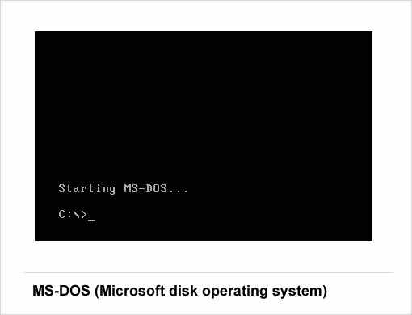

### Windows 1.0 – 2.0 (1985-1992)

Introduced in 1985, [Microsoft Windows](https://www.webopedia.com/TERM/M/Microsoft_Windows.html) 1.0 was named due to the computing boxes, or "[windows](https://www.webopedia.com/TERM/W/window.html)" that represented a fundamental aspect of the operating system. Instead of typing [MS-DOS](https://www.webopedia.com/TERM/D/DOS.html) commands, windows 1.0 allowed users to point and click to access the windows.

In 1987 Microsoft released Windows 2.0, which was designed for the designed for the Intel 286 processor. This version added desktop icons, keyboard shortcuts and improved graphics support.

### Windows 3.0 – 3.1 (1990–1994)

Windows 3.0 was released in May, 1900 offering better [icons](https://www.webopedia.com/TERM/I/icon.html), performance and advanced graphics with 16 colors designed for Intel 386 processors. This version is the first release that provides the standard "look and feel" of Microsoft Windows for many years to come. Windows 3.0 included Program Manager, File Manager and Print Manager and games (Hearts, Minesweeper and Solitaire). Microsoft released Windows 3.1 in 1992.

### Windows 95 (August 1995)

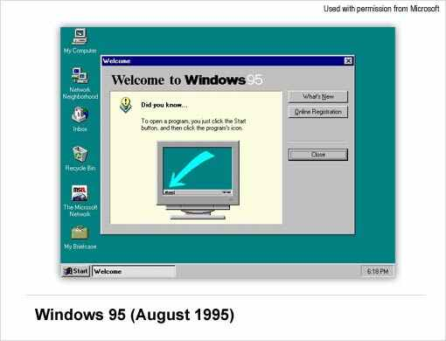

[Windows 95](https://www.webopedia.com/TERM/W/Windows_95.html) was released in 1995 and was a major upgrade to the Windows operating system. This OS was a significant advancement over its precursor, Windows 3.1. In addition to sporting a new user interface, Windows 95 also includes a number of important internal improvements. Perhaps most important, it supports 32-bit applications, which means that applications written specifically for this operating system should run much faster.

Although Windows 95 can run older Windows and DOS applications, it has essentially removed DOS as the underlying platform. This has meant removal of many of the old DOS limitations, such as 640K of main memory and 8-character filenames. Other important features in this operating system are the ability to automatically detect and configure installed hardware (plug and play).

### Windows 98 (June 1998)

[Windows 98](https://www.webopedia.com/TERM/W/Windows_98.html) offers support for a number of new technologies, including FAT32, AGP, MMX, USB, DVD, and ACPI. Its most visible feature, though, is the Active Desktop, which integrates the Web browser (Internet Explorer) with the operating system. From the user's point of view, there is no difference between accessing a document residing locally on the user's hard disk or on a Web server halfway around the world.

### Windows ME - Millennium Edition (September 2000)

The Windows Millennium Edition, called "Windows Me" was an update to the Windows 98 core and included some features of the Windows 2000  operating system. This version also removed the "boot in DOS" option.

### Windows NT 31. - 4.0 (1993-1996)

A version of the Windows operating system. Windows NT (New Technology) is a 32-bit operating system that supports preemptive multitasking. There are actually two versions of Windows NT: Windows NT Server, designed to act as a server in networks, and Windows NT Workstation for stand-alone or client workstations.

### Windows 2000 (February 2000)

Often abbreviated as "W2K," [Windows 2000](https://www.webopedia.com/TERM/W/Windows_2000.html) is an operating system for business desktop and laptop systems to run software applications, connect to Internet and intranet sites, and access files, printers, and network resources. Microsoft released four versions of Windows 2000: Professional (for business desktop and laptop systems), Server (both a Web server and an office server), Advanced Server (for line-of-business applications) and Datacenter Server (for high-traffic computer networks).

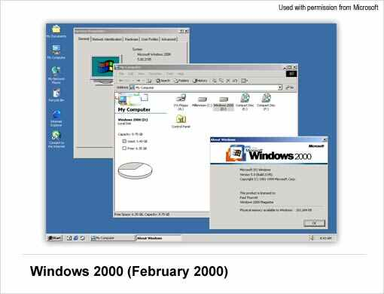

### Windows XP (October 2001)

[Windows XP](https://www.webopedia.com/TERM/W/Windows_XP.html) was released in 2001. Along with a redesigned look and feel to the user interface, the new operating system is built on the Windows 2000 kernel, giving the user a more stable and reliable environment than previous versions of Windows. Windows XP comes in two versions, Home and Professional.  Microsoft focused on mobility for both editions, including plug and play features for connecting to wireless networks. The operating system also utilizes the [802.11x](https://www.webopedia.com/TERM/8/802_11.html) wireless security standard. Windows XP is one of Microsoft's best-selling products.

### Windows Vista (November 2006)

[Windows Vista](https://www.webopedia.com/TERM/W/Windows_Vista.html) offered an advancement in reliability, security, ease of deployment, performance and manageability over Windows XP. New in this version was capabilities to detect hardware problems before they occur, security features to protect against the latest generation of threats, faster start-up time and low power consumption of the new sleep state. In many cases, Windows Vista is noticeably more responsive than Windows XP on identical hardware. Windows Vista simplifies and centralizes desktop configuration management, reducing the cost of keeping systems updated.

### Windows 7 (October, 2009)

[Windows 7](https://www.webopedia.com/TERM/W/Windows_7.html) was released by Microsoft on October 22, 2009 as the latest in the 25-year-old line of Windows operating systems and as the successor to Windows Vista (which itself had followed Windows XP). Windows 7 was released in conjunction with Windows Server 2008 R2, Windows 7's server counterpart. Enhancements and new features in Windows 7 include multi-touch support, Internet Explorer 8, improved performance and start-up time, Aero Snap, Aero Shake, support for virtual hard disks, a new and improved Windows Media Center, and improved security.

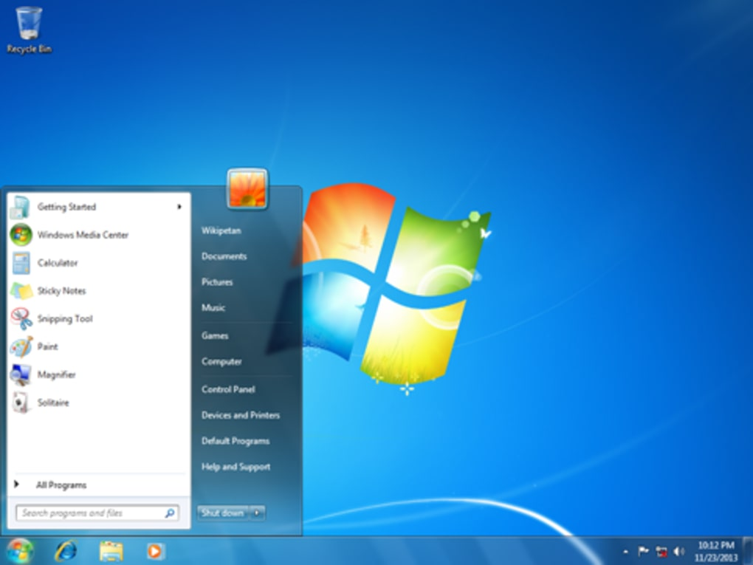

### Windows 8

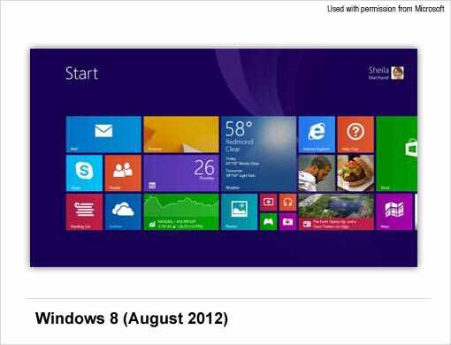

[Windows 8](https://www.webopedia.com/TERM/W/windows_8.html) was released on August. 1, 2012 and is a completely redesigned operating system that's been developed from the ground up with touchscreen use in mind as well as near-instant-on capabilities that enable a Windows 8 PC to load and start up in a matter of seconds rather than in minutes.

Windows 8 will replace the more traditional Microsoft Windows OS look and feel with a new "Metro" design system interface that first debuted in the Windows Phone 7 mobile operating system. The Metro user interface primarily consists of a "Start screen" made up of "Live Tiles," which are links to applications and features that are dynamic and update in real time.  Windows 8 supports both x86 PCs and ARM processors.

### Windows 10

[Windows 10](https://www.webopedia.com/TERM/W/windows-10.html) is Microsoft's Windows successor to Windows 8. Windows 10 debuted on July 29, 2015, following a "technical preview" beta release of the new operating system that arrived in Fall 2014 and a "consumer preview" beta in early 2015. Microsoft claims Windows 10 features fast start up and resume, built-in security and the return of the Start Menu in an expanded form. This version of Windows will also feature Microsoft Edge, Microsoft's new browser. Any qualified device (such as tablets, PCs, smartphones and Xbox consoles) can upgrade to Windows 10, including those with pirated copies of Windows.

## Microsoft Operating Systems for Servers and Mobile Devices

Aside from operating systems designed for use on personal computers (PCs) and laptops, Microsoft has also developed operating systems for services, handheld devices, and mobile phones.

### Windows Server (March 2003)

[Windows Server](https://www.webopedia.com/TERM/W/Windows_Server.html) is a series of Microsoft server operating systems. Windows servers are more powerful versions of their desktop operating system counterparts and are designed to more efficiently handle corporate networking, Internet/intranet hosting, databases, enterprise-scale messaging and similar functions.  The Windows Server name made its debut with the release of Windows Server 2003 and continues with the current release, Windows Server 2008 R2, which shares its codebase with Windows 7. Windows Server 2008 R2 debuted in October 2009.

### Windows Home Server (January 2007)

Announced in January 2007, [Windows Home Server (WHS)](https://www.webopedia.com/TERM/W/Windows_Home_Server.html) is a "consumer server" designed to use with multiple computers connected in the home. Home Server allows you to share files such as digital photos and media files, and also allows you to automatically backup your home networked computers. Through Windows Media Connect, Windows Home Server lets you share any media located on your WHS with compatible devices.

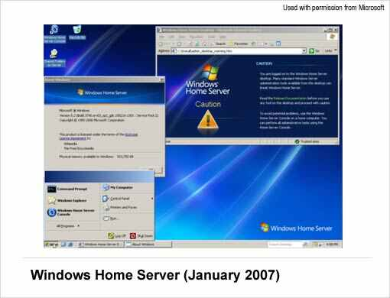

### Windows CE (November 2006)

A version of the Windows operating system designed for small devices such as personal digital assistants (PDAs) (or Handheld PCs in the Microsoft vernacular). The Windows CE graphical user interface (GUI) is very similar to Windows 95 so devices running Windows CE should be easy to operate for anyone familiar with Windows 95.

### Windows Mobile (April 2000)

A mobile operating system for smartphones and mobile devices from Microsoft based on the Windows CE kernel and designed to look and operate similar to desktop versions of Microsoft Windows. [Windows Mobile](https://www.webopedia.com/TERM/W/windows_mobile.html) has largely been supplanted by Windows Phone 7, although Microsoft did release,  in 2011, Windows Embedded Handheld 6.5, a mobile OS compatible with Windows Mobile 6.5 that's designed for enterprise mobile and handheld computing devices.

### Windows Phone (November 2010)

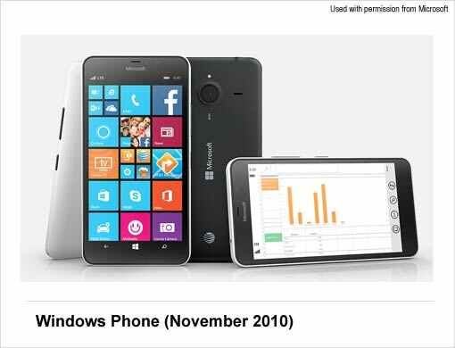

A mobile operating system for smartphones and mobile devices that serves as the successor to Microsoft's initial mobile OS platform system, Windows Mobile. Unlike Windows Mobile, [Windows Phone 7](https://www.webopedia.com/TERM/W/windows_phone.html) (also referred to as WinPhone7) is targeted more to the consumer market than the enterprise market, and it replaces the more traditional Microsoft Windows OS look and feel with a new "Metro" design system user interface.

Windows Phone 7 features a multi-tab Internet Explorer Mobile Web browser that uses a rendering engine based on Internet Explorer 9 as well Microsoft Office Mobile, a version of Microsoft Office that’s tailored for mobile devices. Its successors include Windows Phone 8 and Windows 10 Mobile.

**versions of Windows Operating System (in short)−**

|  |  |  |  |
| --- | --- | --- | --- |
| **Version** | **Year** | **Version** | **Year** |
| Window 1.01 | 1985 | Windows XP Professional x64 | 2005 |
| Windows NT 3.1 | 1993 | Windows Vista | 2007 |
| Windows 95 | 1995 | Windows 7 | 2009 |
| Windows 98 | 1998 | Windows 8 | 2012 |
| Windows 2000 | 2000 | Windows 10 | 2015 |
| Windows ME | 2000 | Windows Server 2016 | 2016 |
| Windows XP | 2001 |  |  |

### Elements of Windows OS

Following are the significant element of **W**indows **O**perating **S**ystem (WOS) −

* Graphical User Interface
* Icons (pictures, documents, application, program icons, etc.)
* Taskbar
* Start button
* Windows explorer
* Mouse button
* Hardware compatibility
* Software compatibility
* Help, etc.

## [Features of Windows OS and Advantages and Disadvantages of Windows OS](http://cybercomputing.blogspot.com/2014/08/Features-of-Windows-OS-and-Advantages-and-Disadvantages-of-Windows-OS.html)

## Best Features of Windows Operating System

### 1. Speed

Even aside from incompatibilities and other issues that many people had with Vista, one of the most straightforward was speed – it just felt too sluggish compared to XP, even on pumped up hardware. Windows 7 brings a more responsive and sprightly feel and Microsoft has spent a lot of time and effort getting the Start Menu response just right.

Microsoft has also recognized the need for improved desktop responsiveness, which gives the impression that the computer is responding to the user and that they are in control – something that was often lacking with Vista.

You can also expect faster boot times. And the boot sequence is now not only prettier than it was with Vista, but it’s speedier too.

### 2. Compatibility

In simple terms, compatibility on Windows 7 will be far better than it was with Vista. Many programs that individuals and companies used on Windows XP did not work immediately and required updates, but with Windows 7 almost all applications that work on Vista should still run.

### 3. Lower Hardware Requirements

Vista gained a reputation for making even the beefiest hardware look rather ordinary. Windows 7, however, will run well on lower end hardware, making the transition from Window XP less painful.

Microsoft is even pushing Windows 7 for netbooks. This could provide a modern replacement for Windows XP, which has found a new lease of life as the OS of choice on netbooks, supplanting Linux. The downside is that Windows 7 Starter Edition, as it will be called, will be limited to only three applications running at the same time.

### 4. Search and Organization

One of the best things about Windows 7 is the improved search tool, which now rivals Mac OS X’s Spotlight to be able to find what you need quickly and easily. For example, typing ‘mouse’ will bring up the mouse option within the control panel or typing a word will display it and split it up neatly into files, folders and applications.

Also introduced is the concept of Libraries, which takes the ‘My Documents’ concept a stage further. The various Libraries, such as Documents and Pictures, will watch multiple locations which you can add yourself, so you don’t have to keep everything in one place.

### 5. Safety and Security

New security features in Windows include two new authentication methods tailored towards touchscreens (PINs and picture passwords), the addition of antivirus capabilities to Windows Defender (bringing it in parity with Microsoft Security Essentials) Smart Screen filtering integrated into Windows, and support for the "Secure Boot" functionality on UEFI systems to protect against malware infecting the boot process. Family Safety offers Parental controls, which allows parents to monitor and manage their children's activities on a device with activity reports and safety controls. Windows 8 also provides integrated system recovery through the new "Refresh" and "Reset" functions, including system recovery from USB drive. Windows 8's first security patches would be released on November 13, 2012; it would contain three fixes deemed "critical" by the company.

### 6. Interface and Desktop

Windows introduces significant changes to the operating system's user interface, many of which are aimed at improving its experience on tablet computers and other touchscreen devices. The new user interface is based on Microsoft's Metro design language, and uses a Start screen similar to that of Windows Phone as the primary means of launching applications. The Start screen displays a customizable array of tiles linking to various apps and desktop programs, some of which can display constantly updated information and content through "live tiles". As a form of multitasking, apps can be snapped to the side of a screen. Alongside the traditional Control Panel, a new simplified and touch-optimized settings app known as "PC Settings" is used for basic configuration and user settings. It does not include many of the advanced options still accessible from the normal Control Panel.

[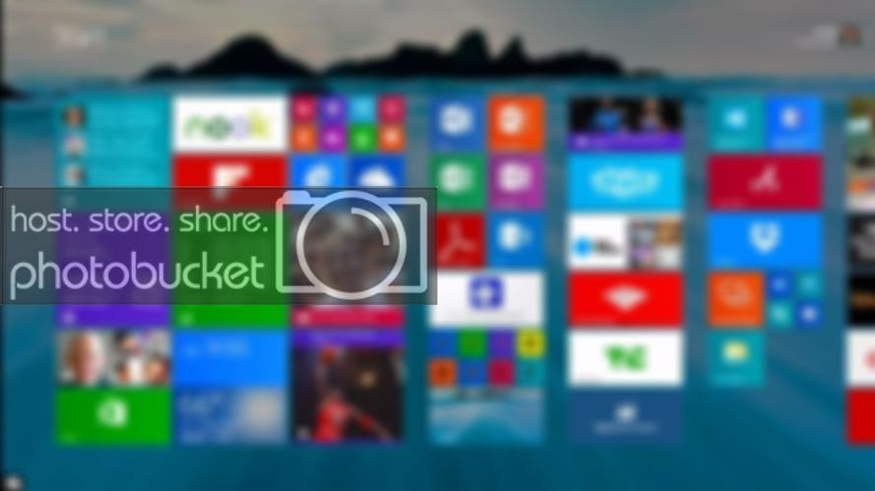](http://i1141.photobucket.com/albums/n594/Muhammad_Soban/Features%20of%20Windows%20OS/MicrosoftWindows811DesktopWallpaper.jpg)

Microsoft Windows 8.1

### 7. Taskbar/Start menu

At first glance, the task bar looks like nothing has much has changed since Vista. In fact, that’s not the case and it’s a lot more powerful. Microsoft is now making best use of its aero technology. By default, taskbar icons are now larger and items are grouped together and are not labelled with clumsy text.

If you have multiple Word documents or Windows Explorer windows open then you’ll see a stack appear on the task bar. Hover the mouse over the app and each Window will be visible in a thumbnail. Hover over each thumbnail and it will become visible, while all other open windows temporarily disappear, save for their outlines. You can close each document or Window down from the thumbnail directly or click on it to bring it to the front.

In the Start menu, a small arrow to the right of applications such as Word now expands to give a list of recent documents and any can be pinned so you can keep one permanently on the list.

## Advantages and Disadvantages of Microsoft Windows

The biggest advantage of Windows is that it provides ready-made solutions that can be implemented by just about anyone who’s ever used a computer.

Microsoft Office is also 100% compatible with any file or document produced in the office space in America. In fact, MS Office isn’t compatible with other software and systems, so much as other software and systems strive to be compatible with Office!

Finally, software services are in large supply when it comes to Windows. From Microsoft’s official services, to Maryland software support, to Microsoft certification training for individuals, there is no lack of software support for Windows.

Of course, Windows detractors will tell you that there is more need for software services when it comes to Windows. And while this worldwide operating system is far from trash, it is often not as stable as its Mac or Linux counterparts.

The only other major disadvantage of using Windows in the workplace is that over 95% of all viruses and malicious software are written for the Windows OS. This means you have to double-down all security measures if you’re using Microsoft software across the board.

**DIFFERENCE BETWEEN DOS AND WINDOWS**

| **S.NO** | **DOS** | **WINDOW** |
| --- | --- | --- |
| 1. | DOS is single tasking operating system. | While windows are multitasking operating systems. |
| 2. | It consumes low power. | While windows consume high power. |
| 3. | It consumes less memory in comparison of windows. | While it consumes more memory. |
| 4. | DOS does not support networking. | While window supports networking. |
| 5. | DOS is complex in terms of using. | Whereas it is simple for using. |
| 6. | DOS does not share time. | While window can share time. |
| 7. | DOS is a command line operating system. | Whereas windows are the graphical operating systems. |
| 8. | DOS operating system is less preferred than windows. | While windows are more preferred by the users in comparison of DOS. |
| 9. | In DOS operating system multimedia is not supported such as: Games, movies,songs etc. | While windows support multimedia such as: Games, movies,songs etc. |
| 10. | In DOS operation systems, operation are performed speedily than windows OS. | While in windows OS, operation are performed slowly than DOS OS. |
| 11. | There is only one window opened at a time in DOS. | While in windows, multiple windows can be opened at a time. |

## UNIX OPERATING SYSTEM

Unix and Unix-like operating systems are a family of computer operating systems that are derived from the original Unix System from Bell Labs.

Initial proprietary derivatives included the HP-UX and the SunOS systems. However, growing incompatibility between these systems led to the creation of interoperability standards like POSIX. Modern POSIX systems include Linux, its variants, and Mac OS.

UNIX is the most powerful and popular multi-user and multi-tasking Operating System. The basic concepts of UNIX were originated in the Multics project of 1969. The Multics system was intended as a time-sharing system that would allow multiple users to simultaneously access a mainframe computer.

Ken Thompson, Dennis Ritchie, and others developed the basic building blocks of Unix including a hierarchical file system, i.e., the concepts of processes and a command line interpreter for the PDP-7. From there, multiple generations of Unix were developed for various machines.

Growing incompatibility between these systems led to the creation of interoperability standards like POSIX and Single UNIX Specification.

UNIX programs are designed around some core philosophies that include requirements like single purpose, interoperable, and working with a standardized text interface. UNIX systems are built around a core kernel that manages the system and the other processes.

Kernel subsystems may include process management, file management, memory management, network management and others.

**There are several prominent features of UNIX, and few among them are stated below:**

* It is a multi-user system where the same resources can be shared by different users.
* It provides multi-tasking, wherein each user can execute many processes at the same time.
* It was the first operating system that was written in a high-level language (C Language). This made it easy to port to other machines with minimum adaptations.
* It provides a hierarchical file structure which allows easier access and maintenance of data.
* Unix has built-in networking functions so that different users can easily exchange information.
* Unix functionality can be extended through user programs built on a standard programming interface.

### UNIX Architecture

[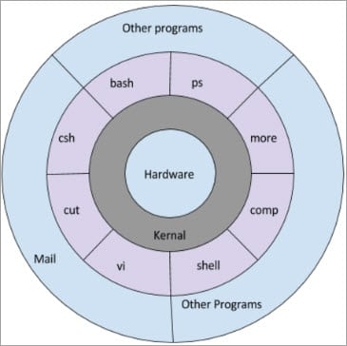](https://cdn.softwaretestinghelp.com/wp-content/qa/uploads/2018/05/Unix-Archeitecture-1.jpg)

We will understand how user commands are executed in UNIX. User commands are often entered on a command line interface that is provided by a ‘shell’. The shell is a program that reads the user commands, evaluates it, and then prints the result. For evaluating the command, the shell may execute other commands, or pass them to the ‘kernel’.

The kernel is the core of the operating system that directly interacts with the underlying hardware to provide a set of standard services.

**Difference between Unix and Linux –**  
Linux is essentially a clone of Unix. But, basic differences are shown below:

| **LINUX** | **UNIX** |
| --- | --- |
| The source code of Linux is freely available to its users | The source code of Unix is not freely available general public |
| It has graphical user interface along with command line interface | It only has command line interface |
| Linux OS is portable, flexible, and can be executed in different hard drives | Unix OS is not portable |
| Different version of Linux are Ubuntu, Linux Mint, RedHot, Solaries, etc. | Different version of Unix are AIS, HP-UX, BSD, Iris, etc. |
| The file systems supported by Linux are as follows: xfs, ramfs, vfat, cramfsm, ext3, ext4, ext2, ext1, ufs, autofs, devpts, ntfs | The file systems supported by Unix are as follows: zfs, js, hfx, gps, xfs, vxfs |

**INTRODUCTION TO PROGRAMMING LANGUAGES**

A computer is a computational device which is used to process the data under the control of a computer program.

Program is a sequence of instruction along with data. While executing the program, raw data is processed into a desired output format.

These computer programs are written in a programming language which is high level languages.

High level languages are nearly human languages which are more complex then the computer understandable language which are called machine language, or low level language.

Between high-level language and machine language there are assembly language also called symbolic machine code.

Assembly languages are particularly computer architecture specific. Utility program (**Assembler**) is used to convert assembly code into executable machine code.

High Level Programming Language are portable but require Interpretation or compiling toconvert it into a machine language which is computer understood.

**Hierarchy of Computer language –**

https://media.geeksforgeeks.org/wp-content/uploads/pl-1.png

There have been many programming language some of them are listed below:

|  |  |  |
| --- | --- | --- |
| **C** | **Python** | **C++** |
| **C#** | **R** | **Ruby** |
| **COBOL** | **ADA** | **Java** |
| **Fortran** | **BASIC** | **Altair BASIC** |
| **True BASIC** | **Visual BASIC** | **GW BASIC** |
| **QBASIC** | **PureBASIC** | **PASCAL** |
| **Turbo Pascal** | **GO** | **ALGOL** |
| **LISP** | **SCALA** | **Swift** |
| **Rust** | **Prolog** | **Reia** |
| **Racket** | **Scheme** | **Shimula** |
| **Perl** | **PHP** | **Java Script** |
| **CoffeeScript** | **VisualFoxPro** | **Babel** |
| **Logo** | **Lua** | **Smalltalk** |
| **Matlab** | **F** | **F#** |
| **Dart** | **Datalog** | **dbase** |
| **Haskell** | **dylan** | **Julia** |
| **ksh** | **metro** | **Mumps** |
| **Nim** | **OCaml** | **pick** |
| **TCL** | **D** | **CPL** |
| **Curry** | **ActionScript** | **Erlang** |
| **Clojure** | **DarkBASCIC** | **Assembly** |

**Characteristics of a programming Language –**

* A programming language must be simple, easy to learn and use, have good readability and human recognizable.
* Abstraction is a must-have Characteristics for a programming language in which ability to define the complex structure and then its degree of usability comes.
* A portable programming language is always preferred.
* Programming language’s efficiency must be high so that it can be easily converted into a machine code and executed consumes little space in memory.
* A programming language should be well structured and documented so that it is suitable for application development.
* Necessary tools for development, debugging, testing, and maintenance of a program must be provided by a programming language.
* A programming language should provide single environment known as Integrated Development Environment (IDE).
* A programming language must be consistent in terms of syntax and semantics.

# COMPILER AND INTERPRETER

## What is Compiler?

A compiler is a computer program that transforms code written in a high-level programming language into the machine code. It is a program which translates the human-readable code to a language a computer processor understands (binary 1 and 0 bits). The computer processes the machine code to perform the corresponding tasks.

A compiler should comply with the syntax rule of that programming language in which it is written. However, the compiler is only a program and cannot fix errors found in that program. So, if you make a mistake, you need to make changes in the syntax of your program. Otherwise, it will not compile.

## What is Interpreter?

An interpreter is a computer program, which coverts each high-level program statement into the machine code. This includes source code, pre-compiled code, and scripts. Both compiler and interpreters do the same job which is converting higher level programming language to machine code. However, a compiler will convert the code into machine code (create an exe) before program run. Interpreters convert code into machine code when the program is run.

### HIGH-LEVEL LANGUAGES

High-level languages, like C, C++, JAVA, etc., are very near to English. It makes programming process easy. However, it must be translated into machine language before execution. This translation process is either conducted by either a compiler or an interpreter. Also known as source code.

### MACHINE CODE

Machine languages are very close to the hardware. Every computer has its machine language. A machine language programs are made up of series of binary pattern. (Eg. 110110) It represents the simple operations which should be performed by the computer. Machine language programs are executable so that they can be run directly.

### OBJECT CODE

On compilation of source code, the machine code generated for different processors like Intel, AMD, an ARM is different. tTo make code portable, the source code is first converted to Object Code. It is an intermediary code (similar to machine code) that no processor will understand. At run time, the object code is converted to the machine code of the underlying platform.

### Java is both Compiled and Interpreted.

To exploit relative advantages of compilers are interpreters some programming language like Java are both compiled and interpreted. The Java code itself is compiled into Object Code. At run time, the JVM interprets the Object code into machine code of the target computer.

[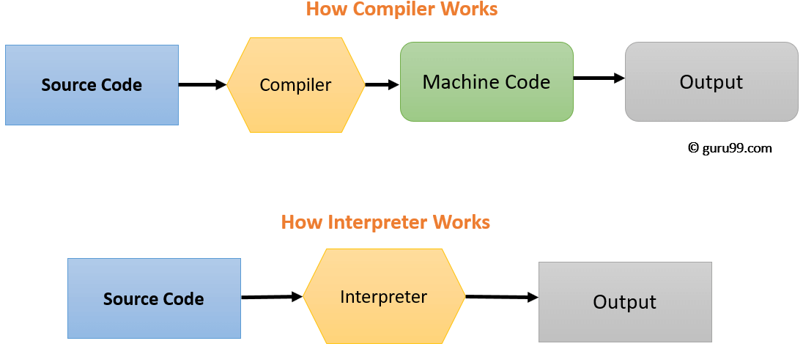](https://www.guru99.com/images/1/053018_0616_CompilervsI1.png)

## Difference between Compiler and Interpreter

|  |  |
| --- | --- |
| **INTERPRETER** | **COMPILER** |
| Translates program one statement at a time. | Scans the entire program and translates it as a whole into machine code. |
| It takes less amount of time to analyze the source code but the overall execution time is slower. | It takes large amount of time to analyze the source code but the overall execution time is comparatively faster. |
| No intermediate object code is generated, hence are memory efficient. | Generates intermediate object code which further requires linking, hence requires more memory. |
| Continues translating the program until the first error is met, in which case it stops. Hence debugging is easy. | It generates the error message only after scanning the whole program. Hence debugging is comparatively hard. |
| Programming language like Python, Ruby use interpreters. | Programming language like C, C++ use compilers. |

## Generations of programming language

[Programming languages](https://www.includehelp.com/basics/computer-programming-languages.aspx) have been developed over the year in a phased manner. Each phase of developed has made the programming language more user-friendly, easier to use and more powerful. Each phase of improved made in the development of the programming languages can be referred to as a generation. The programming language in terms of their performance reliability and robustness can be grouped into five **different generations**,

1. First generation languages (1GL)
2. Second generation languages (2GL)
3. Third generation languages (3GL)
4. Fourth generation languages (4GL)
5. Fifth generation languages (5GL)

### 1. First Generation Language (Machine language)

The first generation programming language is also called low-level programming language because they were used to program the computer system at a very low level of abstraction. i.e. at the machine level. The machine language also referred to as the native language of the computer system is the first generation programming language. In the machine language, a programmer only deals with a binary number.

**Advantages of first generation language**

* They are translation free and can be directly executed by the computers.
* The programs written in these languages are executed very speedily and efficiently by the CPU of the computer system.
* The programs written in these languages utilize the memory in an efficient manner because it is possible to keep track of each bit of data.

### 2. Second Generation language (Assembly Language)

The second generation programming language also belongs to the category of low-level- programming language. The second generation language comprises assembly languages that use the concept of mnemonics for the writing program. In the assembly language, symbolic names are used to represent the opcode and the operand part of the instruction.

**Advantages of second generation language**

* It is easy to develop understand and modify the program developed in these languages are compared to those developed in the first generation programming language.
* The programs written in these languages are less prone to errors and therefore can be maintained with a great case.

### 3. Third Generation languages (High-Level Languages)

The third generation programming languages were designed to overcome the various limitations of the first and second generation programming languages. The languages of the third and later generation are considered as a high-level language because they enable the programmer to concentrate only on the logic of the programs without considering the internal architecture of the computer system.

**Advantages of third generation programming language**

* It is easy to develop, learn and understand the program.
* As the program written in these languages are less prone to errors they are easy to maintain.
* The program written in these languages can be developed in very less time as compared to the first and second generation language.

**Examples:** FORTRAN, ALGOL, COBOL, C++, C

### 4. Fourth generation language (Very High-level Languages)

The languages of this generation were considered as very high-level programming languages required a lot of time and effort that affected the productivity of a programmer. The fourth generation programming languages were designed and developed to reduce the time, cost and effort needed to develop different types of software applications.

**Advantages of fourth generation languages**

* These programming languages allow the efficient use of data by implementing the various database.
* They require less time, cost and effort to develop different types of software applications.
* The program developed in these languages are highly portable as compared to the programs developed in the languages of other generation.

**Examples:** SOL, CSS, coldfusion

### 5. Fifth generation language (Artificial Intelligence Language)

The programming languages of this generation mainly focus on constraint programming. The major fields in which the fifth generation programming language are employed are Artificial Intelligence and Artificial Neural Networks

**Advantages of fifth generation languages**

* These languages can be used to query the database in a fast and efficient manner.
* In this generation of language, the user can communicate with the computer system in a simple and an easy manner.

**Examples:** mercury, prolog, OPS5

## COMPUTER VIRUS

* A computer virus is a malicious program that self-replicates by copying itself to another program. In other words, the computer virus spreads by itself into other executable code or documents.
* The purpose of creating a computer virus is to infect vulnerable systems, gain admin control and steal user sensitive data.
* Hackers design computer viruses with malicious intent and prey on online users by tricking them.
* One of the ideal methods by which viruses spread is through emails – opening the attachment in the email, visiting an infected website, clicking on an executable file, or viewing an infected advertisement can cause the virus to spread to your system.
* Besides that, infections also spread while connecting with already infected removable storage devices, such as USB drives.
* It is quite easy and simple for the viruses to sneak into a computer by dodging the defense systems.
* A successful breach can cause serious issues for the user such as infecting other resources or system software, modifying or deleting key functions or applications and copy/delete or encrypt data.

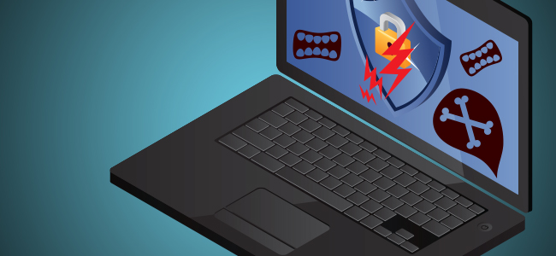

### The History of Computer Virus

* Robert Thomas, an engineer at BBN Technologies developed the first known computer virus in the year 1971.
* The first virus was christened as the “Creeper” virus, and the experimental program carried out by Thomas infected mainframes on ARPANET. The teletype message displayed on the screens read, “I’m the creeper: Catch me if you can.”
* But the original wild computer virus, probably the first one to be tracked down in the history of computer viruses was “Elk Cloner.”
* The Elk Cloner infected Apple II operating systems through floppy disks.
* The message displayed on infected Apple Computers was a humorous one.
* The virus was developed by Richard Skrenta, a teenager in the year 1982.
* Even though the computer viruses were designed as a prank, it also enlightened how a malicious program could be installed in a computer’s memory and stop users from removing the program.
* It was Fred Cohen, who coined the term “computer virus” and it was after a year in 1983.
* The term came into being when he attempted to write an academic paper titled “Computer Viruses – Theory and Experiments” detailing about the malicious programs in his work.

**Signs of Virus Infection**

It is vital for any computer user to be aware of these warning signs –

• Slower system performance  
• Pop-ups bombarding the screen  
• Programs running on their own  
• Files multiplying/duplicating on their own  
• New files or programs in the computer  
• Files, folders or programs getting deleted or corrupted  
• The sound of a hard drive

## How Does Virus Affect?

* By downloading files from the Internet.
* During the removable of media or drives.
* Through pen drive.
* Through e-mail attachments.
* Through unpatched software & services.
* Through unprotected or poor administrator passwords.

## Impact of Virus

* Disrupts the normal functionality of respective computer system.
* Disrupts system network use.
* 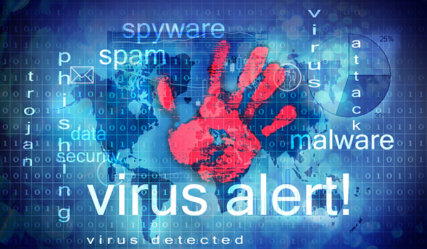Modifies configuration setting of the system.
* Destructs data.
* Disrupts computer network resources.
* Destructs of confidential data.

## Types of Virus

Following are the major types of computer virus −

### Worms

Computer worm is similar to virus but is technically different from virus. It can replicate and spread like virus but unlike viruses it don't need a host program to spread. Being able to self replicate it can produce multiple copies of itself. It spreads through networks such as an email sent to an infected email id can infect your system with computer worm.

### Trojan Horse

Trojan horse is a malware like a virus or worm but it is technically different from both. It can't replicate like virus and worm. Trojan horse hides itself in a program. Once you install any such program the trojan horse enters into your computer. It can provide unauthorized access to your computer, send your files to other computers and may delete files or can make other unwanted changes in your computer.

### Bombs

It is similar to Trojan Horse, but Logic bombs have some specialty; these include a timing device and hence it will go off only at a particular date and time.

**Other types of virus :**

1. **File Virus :**This type of virus infects the system by appending itself to the end of a file. It changes the start of a program so that the control jumps to its code. After the execution of its code, the control returns back to the main program. Its execution is not even noticed. It is also called **Parasitic virus**because it leaves no file intact but also leaves the host functional.
2. **Boot sector Virus :**It infects the boot sector of the system, executing every time system is booted and before operating system is loaded. It infects other bootable media like floppy disks. These are also known as **memory virus** as they do not infect file system.  
   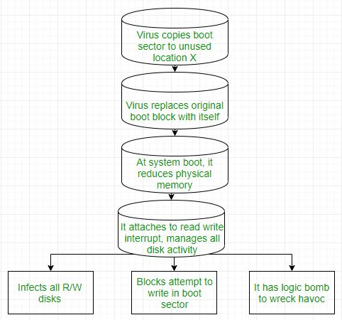
3. **Macro Virus :**Unlike most virus which are written in low-level language(like C or assembly language), these are written in high-level language like Visual Basic. These viruses are triggered when a program capable of executing a macro is run. For example, macro virus can be contained in spreadsheet files.
4. **Source code Virus :**It looks for source code and modifies it to include virus and to help spread it.
5. **Polymorphic Virus :**A **virus signature** is a pattern that can identify a virus(a series of bytes that make up virus code). So in order to avoid detection by antivirus a polymorphic virus changes each time it is installed. The functionality of virus remains same but its signature is changed.
6. **Encrypted Virus :**In order to avoid detection by antivirus, this type of virus exists in encrypted form. It carries a decryption algorithm along with it. So the virus first decrypts and then executes.
7. **Stealth Virus :** It is a very tricky virus as it changes the code that can be used to detect it. Hence, the detection of virus becomes very difficult. For example, it can change the read system call such that whenever user asks to read a code modified by virus, the original form of code is shown rather than infected code.
8. **Tunneling Virus :**This virus attempts to bypass detection by antivirus scanner by installing itself in the interrupt handler chain. Interception programs, which remain in the background of an operating system and catch viruses, become disabled during the course of a tunneling virus. Similar viruses install themselves in device drivers.
9. **Multipartite Virus :**This type of virus is able to infect multiple parts of a system including boot sector,memory and files. This makes it difficult to detect and contain.

## 10. Armored Virus : An armored virus is coded to make it difficult for antivirus to unravel and understand. It uses a variety of techniques to do so like fooling antivirus to believe that it lies somewhere else than its real location or using compression to complicate its code.

**11. Resident virus:** Itstays permanently in the primary memory (RAM) of computer. When you start the computer it becomes active and corrupts the files and programs running on the computer.

## Virus Detection

The most fundamental method of detection of virus is to check the functionality of your computer system; a virus affected computer does not take command properly.

However, if there is antivirus software in your computer system, then it can easily check programs and files on a system for virus signatures.

## Virus Preventive Measures

Let us now see the different virus preventive measures. A computer system can be protected from virus through the following −

* Installation of effective antivirus software.
* Patching up the operating system.
* Patching up the client software.
* Putting highly secured Passwords.
* Use of Firewalls.

## Most Effective Antivirus

Following are the most popular and effective antivirus from which you can choose one for your personal computer −

* McAfee Antivirus Plus
* Symantec Norton Antivirus
* Avast Pro Antivirus
* Bitdefender Antivirus Plus
* Kaspersky Anti-Virus