PROBLEM SOLVING METHODOLOGY

DEFINITION-

Problem solving methodology is a process of working through details of a problem to reach a solution . problem solving may include mathematical or systematic operation and can be a gauge of an individual’s critical thinking skill.

Steps of Problem solving methodology

- Understand the problem- collect the problem to generate a program.
- Analyze the problem-analyze the various steps of solving the problem.
- Design the problem-design the problem by creating flowchart and writing algorithm.
- Code the program-create coding by using proper programming language.

ALGORITHM

It is a step by step procedure which defines a set of instruction to be executed in certain order to get the desired output.

Characteristics of algorithm

- Precision – the steps are precisely stated(defined).
- Uniqueness – results of each step are uniquely defined and only depend on the input and the result of the preceding steps.
- Effectiveness- An algorithm is also generally expected to be effective. This means that all of the operations to be performed in the algorithm must be sufficiently basic that they can in principle be done exactly and in a finite length of time.
Example of not effectiveness :e=1+1/1!+1/2!+....add it to x. Not effective because summation of infinite terms.

- Finiteness-An algorithm must always terminate after a finite number of steps.
- Unambiguous- algorithm should be clear and unambiguous. Each steps should be clear and must lead to any one meaning.
Ex: toss a coin . a coin has 2 sides i.e. head and tail. It shows 2 possible values.

Examples
Write an algorithm to add numbers.
Step1-Read the numbers x,y
Step2-sum=x+y
Step3-print sum
Step-4-end

Or you can write

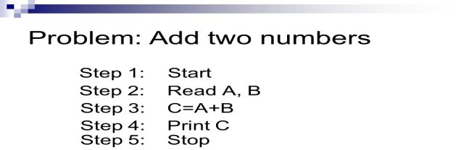

Algorithm

- An algorithm is a step-by-step method for solving some problem.
- An algorithm is a procedure having well defined steps for solving a particular problem.
- Algorithm is finite set of logic or instructions, written in order for accomplish the certain predefined task.
- It is not the complete program or code, it is just a solution (logic) of a problem, which can be represented either as an informal description using a Flowchart or Pseudo code.
Example: Design an algorithm to multiply the two numbers x and y and display the result in z.
- Step 1 START
- Step 2 declare three integers x, y & z
- Step 3 define values of x & y
- Step 4 multiply values of x & y
- Step 5 store the output of step 4 in z
- Step 6 print z
- Step 7 end
. Alternatively the algorithm can be written as ?
- Step 1 START MULTIPLY
- Step 2 get values of x & y
- Step 3 z← x * y
- Step 4 display z
- Step 5 end

Characteristics of an Algorithm
An algorithm must follow the mentioned below characteristics:
- Input: An algorithm must have 0 or well defined inputs.
- Output: An algorithm must have 1 or well defined outputs, and should match with the desired output.
- Feasibility: An algorithm must be terminated after the finite number of steps.
- Independent: An algorithm must have step-by-step directions which is independent of any programming code.
- Unambiguous: An algorithm must be unambiguous and clear. Each of their steps and input/outputs must be clear and lead to only one meaning.

Building Blocks: It has been proven that any algorithm can be constructed from just three basic building blocks. These three building blocks are Sequence, Selection, and Iteration (Repetition).
- SEQUENCE. In a computer program or an algorithm, sequence involves simple steps which are to be executed one after the other. The steps are executed in the same order in which they are written.
Consider an example-1, Algorithm for Addition of two numbers:
Step1: Start (you can also write or start your algorithm from step2 and write the step as step1 without writing step1:start)
Step 2: input two numbers a and b Step 3: set sum=a+b
Step 4: Print sum
Step 5: stop // or step5: end

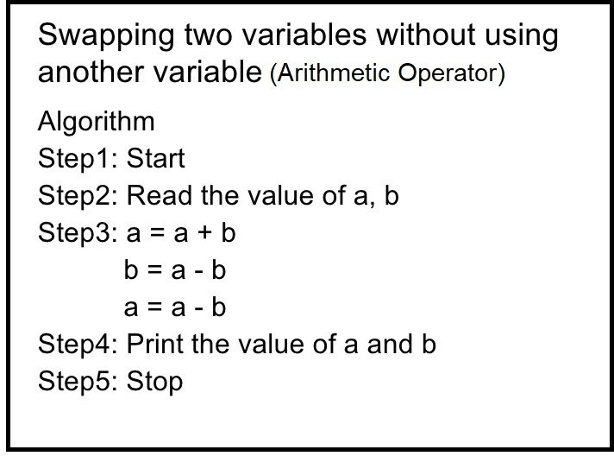
Example-2
you can write step3 as set a=a+b
set b=a-b set a=a-b

Example-3
Swapping of two variables using third variable Step1:read the value of a and b
Step2:set temp=a
Set a=b
Set b=temp
Step3:print the value of a and b Step4: end

Example-4
Algorithm for simple interest.
Step1:read the value of principal, rate and time
Step2:set si=((principal*rate*time)/100)
Step3: print si
Step4:end

All these algorithms perform the steps in a purely sequential order.

- Decision
Decision statements are used when the outcome of the process depends on some condition. Decision means choosing between two actions, depending on whether a condition is true or false.

A decision statement can be stated as following manner:-

Using if
If condition then process Example 1:
Algorithm for check whether a person is eligible to vote.
Step 1: read age
Step 2: if age>=18
Step 3: eligible to vote
Step 4: end
  - Using if-else

if else statement is used to add alternative set of else statements for if condition. In case if condition fails (FALSE) then alternatively it will execute else statements.

Whenever we have specific requirement like execute set of block statements if given condition is TRUE else execute other statements in that situation we can use swift if else statement.

If condition
then process1/statement1
Else
Process2/statement 2

Example 1:algorithm to find whether a number is even or not. Step 1: input a number as a
Step 2:if a%2=0
then print “even”
else
print “odd”
step 3: end
Example-2:
write an algorithm to find the larger among two numbers.
Step 1: input two numbers a and b
Step 2: if a>b
then print a is larger
else
print b is larger
step 3: end

  - Using if else-if else

In, if else-if else statement is used to add alternative set of multiple else-if and single else statements for if condition. In case if condition fails (FALSE) then alternatively check for another condition in case if it failed for all defined conditions the it will execute else statements.

If we want to add multiple condition checks in single program then by using s if else-if else statement we can easily add multiple conditions. In if else-if else statement we have a chance to add multiple else if statements but we are restricted to add only one if and else conditions in statement.

If condition1
then print staement1
else if condition2
then print statement2
else
print statement3

example:

Step 1: input two numbers a and b
Step 2: if a>b then
print a is larger
else if a<b then
print b is larger
else
print the numbers are equal
Step 3: end

3. Repetition/ Iteration :
Repetition allows for a portion of an algorithm or computer program to be executed any number of times dependent on some condition being met. An occurrence of repetition is usually known as a loop. ... This construct is often called a guarded loop. Repeat a block of statements while a condition is true.

It can be implemented using construct such as while, do-while and for loop. First we have to initialize the variable.
    - Using while:

while is used to execute set of statements continuously until, the defined condition is TRUE.
Q.Write an algorithm to print first 10 natural numbers
Step 1: Initialize i=0 , n=10
Step 2: repeat step while n<=10
Step 3: Print i
Step 4: end

Q.Write an algorithm to find the factorial of a number entered by user.

Step 1: Start
Step 2: Declare variables n,factorial and i.
Step 3: Initialize variables
factorial←1 i←1
Step 4: Read value of n
Step 5: Repeat the steps until i=n factorial←factorial*i
i←i+1
Step 6: Display factorial Step 7: end

Using for loop//
using do-while//

PSEUDOCODE

pseudocode is an artificial and informal language that helps programmers develop algorithms.pseudocode is a “text-based”detail(algorithmic) design tool.

It’s simply an implementation of an algorithm in the form of annotations and informative text written in plain English. It has no syntax like any of the programming language and thus can’t be compiled or interpreted by the computer.

How to write a Pseudo Code?
- Pseudo code is a term which is often used in programming and algorithm based fields. It is a methodology that allows the programmer to represent the implementation of an algorithm.
- Simply, we can say that it’s the cooked up representation of an algorithm.
- Often at times, algorithms are represented with the help of pseudo codes as they can be interpreted by programmers no matter what their programming background or knowledge is.
- Pseudo code, as the name suggests, is a false code or a representation of code which can be understood by even a layman with some school level programming knowledge.

Advantages of Pseudo code
- Improves the readability of any approach. It’s one of the best approaches to start implementation of an algorithm.
- Acts as a bridge between the program and the algorithm or flowchart. Also works as a rough documentation, so the program of one developer can be understood easily when a pseudo code is written out. In industries, the approach of documentation is essential. And that’s where a pseudo-code proves vital.
- The main goal of a pseudo code is to explain what exactly each line of a program should do, hence making the code construction phase easier for the programmer.

How to write a Pseudo-code?
Arrange the sequence of tasks and write the pseudocode accordingly.
Start with the statement of a pseudo code which establishes the main goal or the aim.
Example:
This program will allow the user to check
the number whether it's even or odd.
The way the if-else, for, while loops are indented in a program, indent the statements likewise, as it helps to comprehend the decision control and execution mechanism. They also improve the readability to a great extent.

Use appropriate naming conventions. The human tendency follows the approach to follow what we see. If a programmer goes through a pseudo code, his approach will be the same as per it, so the naming must be simple and distinct.
Use appropriate sentence casings, such as CamelCase for methods, upper case for constants and lower case for variables.
Elaborate everything which is going to happen in the actual code. Don’t make the pseudo code abstract.
Use standard programming structures such as ‘if-then’, ‘for’, ‘while’, ‘cases’ the way we use it in programming.
Check whether all the sections of a pseudo code is complete, finite and clear to understand and comprehend.
Don’t write the pseudo code in a complete programmatic manner. It is necessary to be simple to understand even for a layman or client, hence don’t incorporate too many technical terms.

STATEMENTS
A statement is defined as an instruction that directs the computer to perform a specific action. In writing pseudo code, we will refer to singular instructions as statements.
When writing pseudo code, we assume that the order of execution of the statements is from top to bottom. This changes when using control structures, functions and exception handling.

Mathematical operations
Mathematical operations are integral to solution development. They allow us to manipulate the values we have stored.
Here are common mathematical symbols:

Assignment: ← or := Example: c ← 2πr, c := 2πr Comparison: =, ≠, <, >, ≤, ≥Arithmetic: +, −, ×, /, mod , Floor/ceiling: ⌊, ⌋, ⌈, ⌉a ← ⌊b⌋ + ⌈c⌉ Logical: and, or Sums, products: Σ Π Example: h ← Σ a ∈A 1/a
Keywords:A keyword is a word that is reserved by a program because the word has a special meaning. Keywords can be commands or parameters. Every programming language has its own keywords (reserved words). Keywords cannot be used as variable names.
In Pseudocode, they are used to indicate common input-output and processing operations. They are written fully in uppercase.

START: This is the start of your pseudocode.
INPUT: This is data retrieved from the user through typing or through an input device.
READ / GET: This is input used when reading data from a data file.
PRINT, DISPLAY, SHOW: This will show your output to a screen or the relevant output device.
COMPUTE, CALCULATE, DETERMINE: This is used to calculate the result of an expression.
SET, INIT: To initialize values
INCREMENT, BUMP: To increase the value of a variable
DECREMENT: To reduce the value of a variable

CONDITIONALS
During algorithm development, we need statements which evaluate expressions and execute instructions depending on whether the expression evaluated to True or False. Here are some common conditions used in Pseudocode:

IF — ELSE IF — ELSE
This is a conditional that is used to provide statements to be executed if a certain condition is met. This also applies to multiple conditions and different variables.
Here is an if statement with one condition
IF you are happy
THEN smile
ENDIF
Here is an if statement with an else section. Else allows for some statements to be executed if the “if” condition is not met.
IF you are happy THEN
smile
ELSE
frown
ENDIF
We can add additional conditions to execute different statements if met.
IF you are happy THEN
smile
ELSE IF you are sad
frown
ELSE
keep face plain
ENDIF

CASE
Case structures are used if we want to compare a single variable against several conditions.
INPUT colorCASE color of red: PRINT "red"
green: PRINT "green"
blue: PRINT "blue"OTHERS
PRINT "Please enter a value color"ENDCASE
The OTHERS clause with its statement is optional. Conditions are normally numbers or characters

ITERATION
To iterate is to repeat a set of instructions in order to generate a sequence of outcomes. We iterate so that we can achieve a certain goal.

FOR structure
The FOR loop takes a group of elements and runs the code within the loop for each element.
FOR every month in a year Compute number of daysENDFOR

WHILE structure
Similar to the FOR loop, the while loop is a way to repeat a block of code as long as a predefined condition remains true. Unlike the FOR loop, the while loop evaluates based on how long the condition will remain true.
To avoid a scenario where our while loop runs infinitely, we add an operation to manipulate the value within each iteration. This can be through an increment, decrement, et cetera.

PRECONDITION: variable X is equal to 1
WHILE Population < Limit Compute Population as Population + Births — Deaths
ENDWHILE

FUNCTIONS
When solving advanced tasks it is necessary to break down the concepts in block of statements in different locations. This is especially true when the statements in question serve a particular purpose. To reuse this code, we create functions. We can then call these functions every-time we need them to run.
Function clear monitor
Pass In: nothing
Direct the operating system to clear the monitor
Pass Out: nothing
Endfunction
To emulate a function call in pseudocode, we can use the Call keyword
call: clear monitor

Examples of Pseudocode
create a program to add 2 numbers together and then display the result.
Start Program
Enter two numbers, A, B
Add the numbers together
Print Sum
End Program
Compare that pseudocode to an example of a flowchart to add two numbers
PRINT C
END
SET C=A+B
ENTER 2 NOS A,B
START

compute the area of a rectangle:
Get the length, l, and width, w
Compute the area = l*w
Display the area
compute the perimeter of a rectangle:
Enter length, l
Enter width, w
Compute Perimeter = 2*l + 2*w
Display Perimeter of a rectangle

CONCLUSION
There are no technical rules for Pseudocode. It is meant to be human readable and still convey meaning and flow.There are different guide and tutorials which lean more towards language-specific pseudocode, examples of such are Fortran style pseudo code, Pascal style pseudo code, C style pseudo code and Structured Basic style pseudo code.

FLOWCHART

A flowchart is simply a graphical representation of steps. It shows steps in sequential order and is widely used in presenting the flow of algorithms, workflow or processes. Typically, a flowchart shows the steps as boxes of various kinds, and their order by connecting them with arrows.

Guide to Flowchart Symbols, from Basic to Advanced

1. The Oval

An End or a Beginning
The oval, or terminator, is used to represent the start and end of a process. Use the Gliffy flowchart tool to drag and drop one of these bad boys and you've got yourself the beginning of a flowchart. Remember to use the same symbol again to show that your flowchart is complete.

2. The Rectangle

A Step in the Flowcharting Process
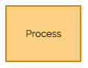
The rectangle is your go-to symbol once you've started flowcharting. It represents any step in the process you’re diagramming and is the workhorse of the flowchart diagram. Use rectangles to capture process steps like basic tasks or actions in your process.

3. The Arrow

Indicate Directional Flow
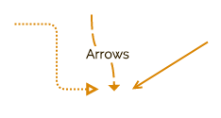
The arrow is used to guide the viewer along their flowcharting path. And while there are many different types of arrow tips to choose from, we recommend sticking with one or two for your entire flowchart. This keeps your diagram looking clean, but also allows you to emphasize certain steps in your process.

4. The Diamond

Indicate a Decision
The diamond symbolizes that a decision is required to move forward. This could be a binary, this-or-that choice or a more complex decision with multiple choices. Make sure that you capture each possible choice within your diagram.
With those four basic symbols, you likely have everything you need to get started on your own flowchart! Give it a try with Gliffy or read on for more info on intermediate flowcharting symbols.

Intermediate & Advanced Flowchart Symbols
As you know, flowcharts are made up of a sequence of actions, data, services, and/or materials. They illustrate where data is being input and output, where information is being stored, what decisions need to be made, and which people need to be involved. In addition to the basics, these intermediate flowchart symbols will help you describe your process with even more detail.
Document Symbols
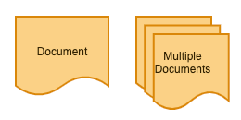
Single and multiple document icons show that there are additional points of reference involved in your flowchart. You might use these to indicate items like “create an invoice” or “review testing paperwork.”

Data Symbols
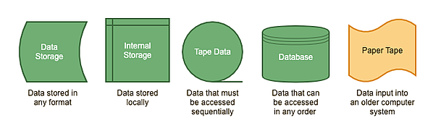
Data symbols clarify where the data your flowchart references is being stored. (You probably won’t use the paper tape symbol, but it definitely came in handy back in the day.)

Input & Output
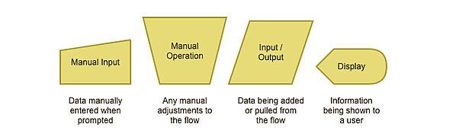
Input and output symbols show where and how data is coming in and out throughout your process.

Merging & Connecting
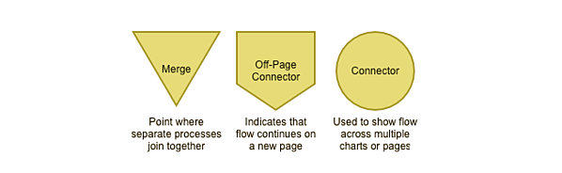
Agreed-upon merging and connector symbols make it easier to connect flowcharts that span multiple pages.

Additional Useful Shapes
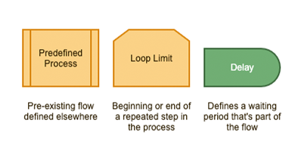
The above are a few additional symbols that prove your flowcharting prowess when put to good use.
Using Flowchart Symbols
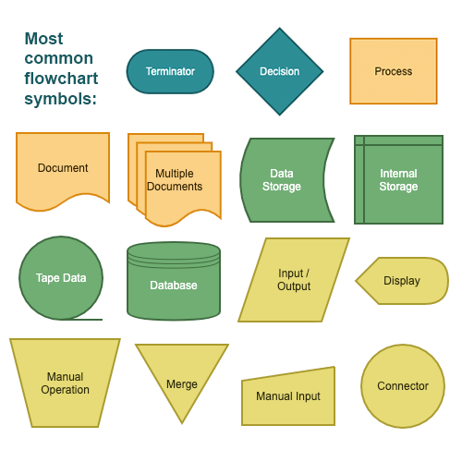

Types of flowcharts
- Document Flowcharts: These “have the purpose of showing existing controls over document-flow through the components of a system. … The chart is read from left to right and documents the flow of documents through the various business units.”
- Data Flowcharts: These show “the controls governing data flows in a system. … Data flowcharts are used primarily to show the channels that data is transmitted through the system rather than how controls flow.”
- System Flowcharts: These “show the flow of data to and through the major components of a system such as data entry, programs, storage media, processors, and communication networks.”
- Program Flowcharts: These show “the controls placed internally to a program within a system.

Example : Draw a flowchart to input two numbers from user and display the largest of two numbers
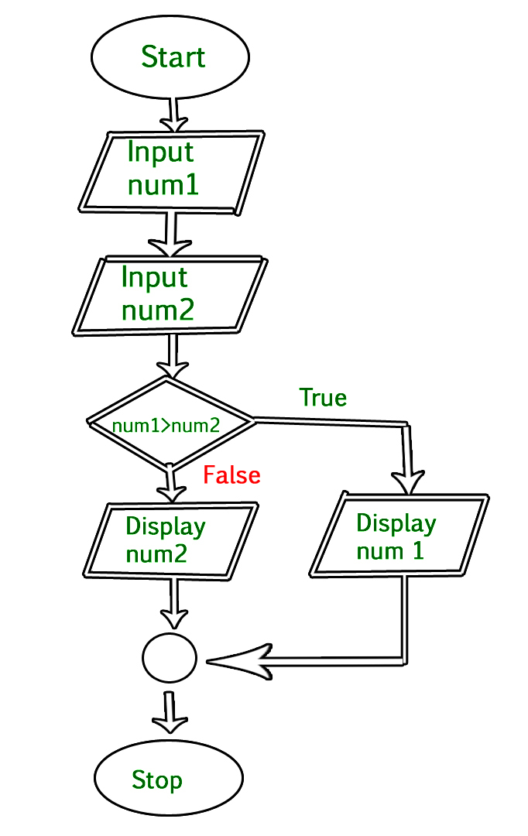

Q1. Add 10 and 20

Flowchart
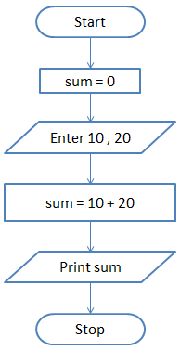

Q2. Find the sum of 5 numbers

Flowchart

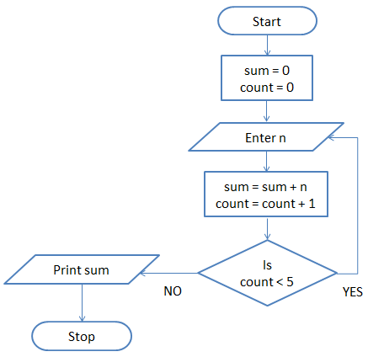

Q3. Print Hello World 10 times

Flowchart
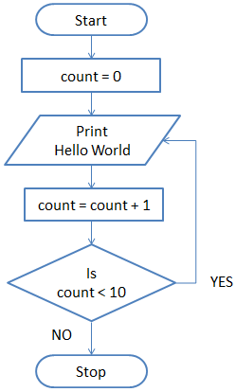

Q4. Draw a flowchart to log in to facebook account.

Flowchart
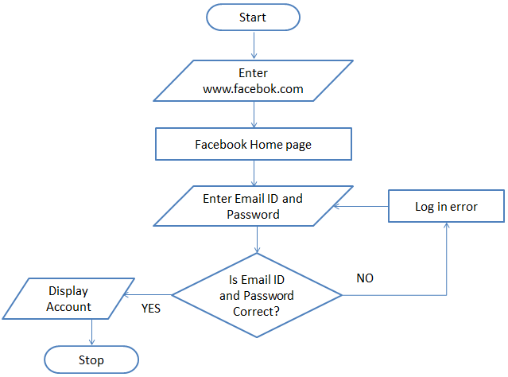
Draw flowchart to find the largest among three different numbers entered by user.
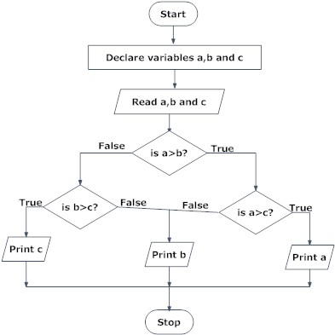

Draw a flowchart to find all the roots of a quadratic equation ax²+bx+c=0
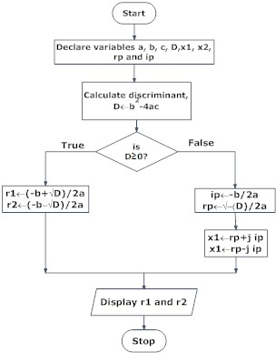
Draw a flowchart to find the Fibonacci series till term≤1000.
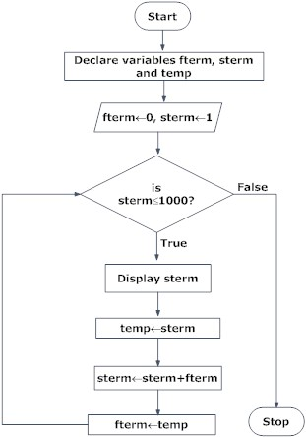

Flowchart for calculate factorial value of a number:
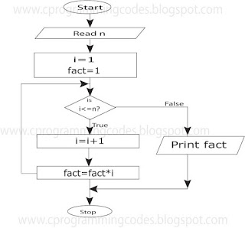

Difference between Algorithm and Flowchart
Algorithm | Flowchart
It is a procedure for solving problems. | It is a graphic representation of a process.
The process is shown in step-by-step instruction. | The process is shown in block-by-block information diagram.
It is complex and difficult to understand. | It is intuitive and easy to understand.
It is convenient to debug errors. | It is hard to debug errors.
The solution is showcased in natural language. | The solution is showcased in pictorial format.
It is somewhat easier to solve complex problem. | It is hard to solve complex problem.
It costs more time to create an algorithm. | It costs less time to create a flowchart.

Generations of programming language
Programming languages have been developed over the year in a phased manner. Each phase of developed has made the programming language more user-friendly, easier to use and more powerful. Each phase of improved made in the development of the programming languages can be referred to as a generation. The programming language in terms of their performance reliability and robustness can be grouped into five different generations,
- First generation languages (1GL)
- Second generation languages (2GL)
- Third generation languages (3GL)
- Fourth generation languages (4GL)
- Fifth generation languages (5GL)

1. First Generation Language (Machine language)
The first generation programming language is also called low-level programming language because they were used to program the computer system at a very low level of abstraction. i.e. at the machine level. The machine language also referred to as the native language of the computer system is the first generation programming language. In the machine language, a programmer only deals with a binary number.
Advantages of first generation language
- They are translation free and can be directly executed by the computers.
- The programs written in these languages are executed very speedily and efficiently by the CPU of the computer system.
- The programs written in these languages utilize the memory in an efficient manner because it is possible to keep track of each bit of data.

2. Second Generation language (Assembly Language)
The second generation programming language also belongs to the category of low-level- programming language. The second generation language comprises assembly languages that use the concept of mnemonics for the writing program. In the assembly language, symbolic names are used to represent the opcode and the operand part of the instruction.
Advantages of second generation language
- It is easy to develop understand and modify the program developed in these languages are compared to those developed in the first generation programming language.
- The programs written in these languages are less prone to errors and therefore can be maintained with a great case.

3. Third Generation languages (High-Level Languages)
The third generation programming languages were designed to overcome the various limitations of the first and second generation programming languages. The languages of the third and later generation are considered as a high-level language because they enable the programmer to concentrate only on the logic of the programs without considering the internal architecture of the computer system.
Advantages of third generation programming language
- It is easy to develop, learn and understand the program.
- As the program written in these languages are less prone to errors they are easy to maintain.
- The program written in these languages can be developed in very less time as compared to the first and second generation language.
Examples: FORTRAN, ALGOL, COBOL, C++, C

4. Fourth generation language (Very High-level Languages)
The languages of this generation were considered as very high-level programming languages required a lot of time and effort that affected the productivity of a programmer. The fourth generation programming languages were designed and developed to reduce the time, cost and effort needed to develop different types of software applications.
Advantages of fourth generation languages
- These programming languages allow the efficient use of data by implementing the various database.
- They require less time, cost and effort to develop different types of software applications.
- The program developed in these languages are highly portable as compared to the programs developed in the languages of other generation.
Examples: SOL, CSS, ColdFusion

5. Fifth generation language (Artificial Intelligence Language)
The programming languages of this generation mainly focus on constraint programming. The major fields in which the fifth generation programming language are employed are Artificial Intelligence and Artificial Neural Networks
Advantages of fifth generation languages
- These languages can be used to query the database in a fast and efficient manner.
- In this generation of language, the user can communicate with the computer system in a simple and an easy manner.
Examples: mercury, prolog, OPS5

Structured Programming Approach with Advantages and Disadvantages
Structured Programming Approach, as the word suggests, can be defined as a programming approach in which the program is made as a single structure. It means that the code will execute the instruction by instruction one after the other. It doesn’t support the possibility of jumping from one instruction to some other with the help of any statement like GOTO, etc. Therefore, the instructions in this approach will be executed in a serial and structured manner. The languages that support Structured programming approach are:
- C
- C++
- Java
- C#
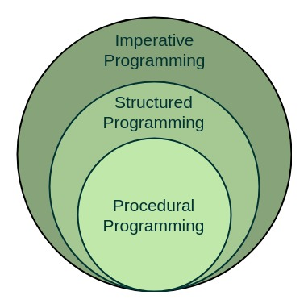
On the contrary, in the Assembly languages like Microprocessor 8085, etc, the statements do not get executed in a structured manner. It allows jump statements like GOTO. So the program flow might be random.

Advantages Of Structured Programming Language
- Structured programming is user-friendly and easy to understand.
- In this programming, programs are easier to read and learn.
- It avoids the increased possibility of data corruption.
- The main advantage of structured programming is reduced complexity.
- Increase the productivity of application program development.
- Application programs are less likely to contain logic errors.
- Errors are more easily found.
- It is easier to maintain.
- It is independent of the machine on which it is used, i.e. programs developed in high-level languages can be run on any computer.

Disadvantages Of Structured Programming Language
- Same code repetition
The code that is written may appear in different parts of the program. It can be vulnerable to various problems because of its location. Programs have variables, which means that they can take on different values at different parts of the program.
- Lack of encapsulation
Its lack of availability in structured programming means that programs will be longer.
- Lack of information hiding
Information hiding involves isolating design decisions in a computer program that have the greatest chance to change. This protects other parts of the program from modifications if the design decision is changed.

