**WEB**

**DEVELOPMENT**

**LAB MANUAL**

**CHAPTER-1**

**INTRODUCTIO TO HTML**

**HTML**

* HTML stands for Hyper Text Markup Language.
* HTML describes the structure of a Web page
* HTML consists of a series of elements.
* HTML elements tell the browser how to display the content.
* HTML elements are represented by tags.
* HTML tags label pieces of content such as "heading", "paragraph", "table", and so on.
* Browsers do not display the HTML tags, but use them to render the content of the page.

STRUCTURE OF HTML

<html>  
<head>  
<title>Page Title</title>  
</head>  
<body>  
  
<h1>My First Heading</h1>  
<p>My first paragraph.</p>  
  
</body>  
</html>

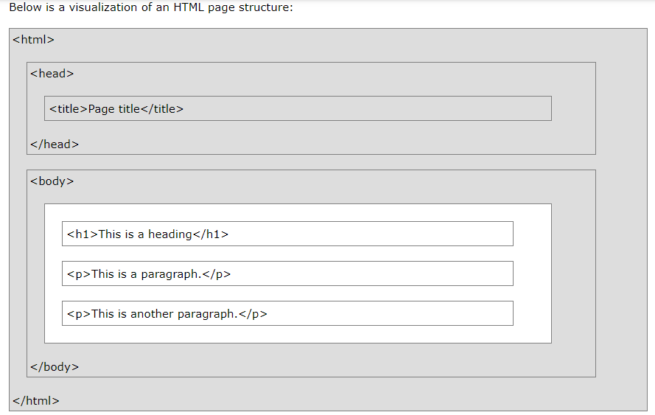

**<!-- PROGRAM TO ILLUSTRATE BODY TAG , PRE TAGS , HN TAG AND PARAGRAPH TAG -->**

**1.WAP TO HTML DISPLAY THE TEXT “SKDAV ”USING DIFFERENT HEADING TAG ?**

<html>

<head>

<tittle>it1</tittle>

</head>

<body bgcolor=pink>

<center>

<h1>skdav</h1>

<h2>skdav</h2>

<h3>skdav</h3>

<h4>skdav</h4>

<h5>skdav</h5>

<h6>skdav</h6>

</center>

</body>

</html>

**OUTPUT:-**

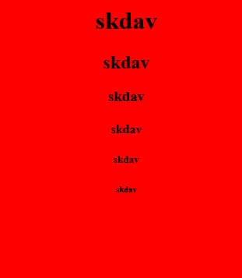

**2.WAP TO HTML TO WRITE A PARAGRAPH?**

<html>

<head>

<tittle>it2</tittle>

</head>

<body bgcolor=yellow>

<h1>html</h1>

<p>HTML is a method through which ordinary text canbe</p>

<p>converted in to hypertext.it is a set of special code technically</p>

<p>HTML is not a programming language.</p>

<p>the language use to devlop web page is called hyper text mark up lnguage.</p>

</body>

</html>

**OUTPUT:-**

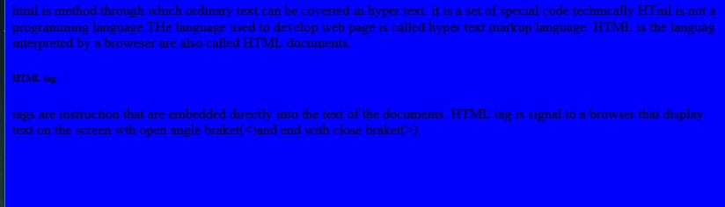

**3.WAP TO HTML PRINT 10 STUDENT DETAILS USING PRE TAG?**

<html>

<head>

<title>it3</title>

</head>

<body bgcolor=green>

<center>

</H1>

STUDENT DETAILS

</center>

<pre>

slno rollno name branch semester

01 f1 ashu it 6th

02 f2 punam it 6th

03 f3 barsha it 6th

04 f4 debas it 6th

05 f5 jyoti it 6th

06 f6 sradha it 6th

07 f7 little it 6th

08 f8 priya it 6th

09 f9 riya it 6th

10 f10 anushka it 6th

</pre>

</H1>

</body>

</html>

**OUTPUT:-**

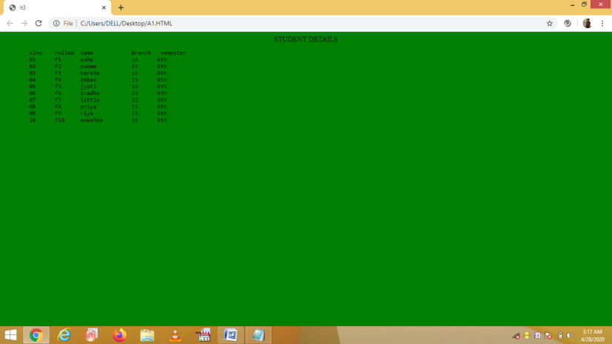

**4.WAP IN HTML TO ENTER PERSONAL DETAILS ?**

<html>

<head>

<title>it4</title>

<center>

<h1>PERSONAL DETAILS</h1>

</center>

</head>

<body bgcolor=gray>

<center><br>

<br>

NAME=HIMANSU SEKHAR PARIJA<br>

<br>

FATHER NAME=ALOK PARIJA<br>

<br>

MOTHER NAME=SAITRI PARIJA<br>

<br>

D.O.B=25.02.2002<br>

<br>

ADDRESS=SALEPUR<br>

<br>

PINCODE=754207<br>

<br>

CITY=SALEPUR<br>

<br>

DIST=CUTTACK<br>

<br>

STATE=ODISHA<br>

<br>

QUALIFICATION=DIPLOMA

</center>

</body>

</html>

**OUTPUT:-**

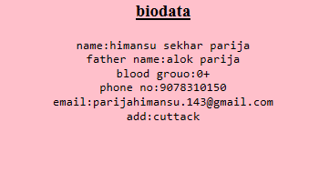

## <!-- PROGRAM TO ILLUSTRATE TEXT MANIPULATION -->

**1.WAP TO HTML BY USING TEXT MANUPULATON.**

<html>

<head>

<title>t5</title>

</head>

<body bgcolor=orange>

<center>

<b>SKDAV</b><br>

<br>

<i> SKDAV </i><br>

<br>

<u> SKDAV </u><br>

<br>

<big> SKDAV </big><br>

<br>

<small> SKDAV </small><br>

<br>

<s> SKDAV </s><br>

<br>

<strike> SKDAV </strike><br>

<br>

<strong> SKDAV </strong><br>

<br>

<tt> SKDAV </tt><br>

<br>

<em> SKDAV </em><br>

</center>

</html>

**OUTPUT:-**

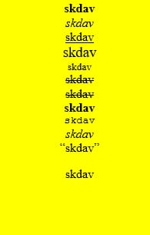

**2.WAP TO HTM L BY USING MARQUEE CODE**

<html>

<head>

<title>it8</title>

<body background="C:\Users\user\Pictures\indira.gif"=orange>

<marquee>SKDAV GOVT POLYTECHNIC</marquee>

</body>

</head>

</html>

**OUTPUT:-**



**CHAPTER-2**

**LIST**

HTML offers web authors three ways for specifying lists of information. All lists must contain one or more list elements. Lists may contain −

* **<ul>** − An unordered list. This will list items using plain bullets.
* **<ol>** − An ordered list. This will use different schemes of numbers to list your items.
* **<dl>** − A definition list. This arranges your items in the same way as they are arranged in a dictionary.

## Ordered List

The type attribute of the [<ol>](https://www.w3schools.com/tags/tag_ol.asp) tag, defines the type of the list item marker:

|  |  |
| --- | --- |
| **Type** | **Description** |
| type="1" | The list items will be numbered with numbers (default) |
| type="A" | The list items will be numbered with uppercase letters |
| type="a" | The list items will be numbered with lowercase letters |
| type="I" | The list items will be numbered with uppercase roman numbers |
| type="i" | The list items will be numbered with lowercase roman numbers |

**<!-- A PROGRAM TO ILLUSTRATE ORDER LIST TAG -->**

<html>

<head>

<title> Order List tag </title>

</head>

<body>

<h3 align="center" style="color:red">To illustrate ORDER list tags</h3>

<hr COLOR="RED">

<h4>Numbered list:</h4>

<ol>

<li>Apples</li>

<li>Bananas</li>

<li>Lemons</li>

<li>Oranges</li>

</ol>

<h4>Uppercase Letters list:</h4>

<ol type="A">

<li>Apples</li>

<li>Bananas</li>

<li>Lemons</li>

<li>Oranges</li>

</ol>

<h4>Lowercase letters list:</h4>

<ol type="a">

<li>Apples</li>

<li>Bananas</li>

<li>Lemons</li>

<li>Oranges</li>

</ol>

<h4>Roman numbers list:</h4>

<ol type="I">

<li>Apples</li>

<li>Bananas</li>

<li>Lemons</li>

<li>Oranges</li>

</ol>

<h4>Lowercase Roman numbers list:</h4>

<ol type="i">

<li>Apples</li>

<li>Bananas</li>

<li>Lemons</li>

<li>Oranges</li>

</ol>

</body>

</html>

**OUTPUT**



## Unordered List

An unordered list starts with the [<ul>](https://www.w3schools.com/tags/tag_ul.asp) tag.

Each list item starts with the [<li>](https://www.w3schools.com/tags/tag_li.asp) tag.

|  |  |
| --- | --- |
| **Value** | **Description** |
| disc | Sets the list item marker to a bullet (default) |
| circle | Sets the list item marker to a circle |
| square | Sets the list item marker to a square |
| none | The list items will not be marked |

**<!-- A PROGRAM TO ILLUSTRATE UNORDER LIST TAG -->**

<html>

<head>

<title> Unorder List </title>

</head>

<body>

<h3 align="center"> To illustrate unorder list tags </h3>

<hr color="red">

<h4>Disc bullets list:</h4>

<ul type="disc">

<li>Apples</li>

<li>Bananas</li>

<li>Lemons</li>

<li>Oranges</li>

</ul>

<h4>Circle bullets list:</h4>

<ul type="circle">

<li>Apples</li>

<li>Bananas</li>

<li>Lemons</li>

<li>Oranges</li>

</ul>

<h4>Square bullets list:</h4>

<ul type="square">

<li>Apples</li>

<li>Bananas</li>

<li>Lemons</li>

<li>Oranges</li>

</ul>

</body>

</html>

**OUTPUT**



## Description Lists

HTML also supports description lists.

A description list is a list of terms, with a description of each term.

The [<dl>](https://www.w3schools.com/tags/tag_dl.asp) tag defines the description list, the [<dt>](https://www.w3schools.com/tags/tag_dt.asp) tag defines the term (name), and the [<dd>](https://www.w3schools.com/tags/tag_dd.asp) tag describes each term:

**<!-- A PROGRAM TO ILLUSTRATE NESTED AND DEFINITION TAG -->**

<html>

<head>

<title> Nested and Definition List <title>

</head>

<body>

<h3 align="center"> To illustrate Nested and Definition List Tags </h3>

<hr color="red">

<h4> An ordered nested List: </h4>

<ol>

<li> Coffee </li>

<li> Tea

<ol type= "a">

<li> Black tea </li>

<li> Green tea </li>

<ol type= "i" >

<li> China </li>

<li> Africa </li>

</ol>

</ol>

<li> Milk </li>

</ol>

<h4> A Definition List: </h4>

<dl>

<dt> Bangalore </dt>

<dd> -Capital City of Karnataka </dd>

<dt> Mumbai</dt>

<dd> -Capital city of Maharashtra </dd>

</dl>

</body>

</html>

**OUTPUT**



**IMAGE**

## HTML Images Syntax

In HTML, images are defined with the <img> tag.

The <img> tag is empty, it contains attributes only, and does not have a closing tag.

The src attribute specifies the URL (web address) of the image.

**<!-- A PROGRAM TO ILLUSTRATE IMG TAG -->**

<html>

<head>

<title> Image Tag </title>

</head>

<body>

<h3 align="center" style="color:red"> To illustrate image tags</h3> <hr>

<p>

<img src="flower.bmp" align="right" height="100" width="100"/>

This image is right aligned with the text

</p>

<br><br><br><br><hr>

<p>

<img src="flower.bmp" align="left" height="100" width="100"/>

This image is left aligned with the text

</p>

<br><br><br><br><hr>

This image is center aligned with the text.

<img src="flower.bmp" align="middle" height="100" width="100"/>

<br><br><br><br><hr>

This image is bottom aligned with the text.

<img src="flower.bmp" align="bottom" height="100" width="100"/>

<br><br><br><br><hr>

This image is top aligned with the text.

<img src="flower.bmp" align="top" height="100" width="100"/>

</body>

</html>

**OUTPUT**



**TABLE**

## Defining an HTML Table

An HTML table is defined with the <table> tag.

Each table row is defined with the <tr> tag. A table header is defined with the <th> tag. By default, table headings are bold and centered. A table data/cell is defined with the <td> tag.

**<!-- A PROGRAM TO ILLUSTRATE TABLE TAG -->**

<html>

<head>

<title>himansu</title>

</head>

<body bgcolor=green>

<center>

<table border=10>

<tr>

<th rowspan=2>name</th>

<th colspan=3>mrk</th>

</tr>

<tr>

<th>wd</th>

<th>fet</th>

<th>project</th>

</tr>

<tr>

<td>himansu</td>

<td>100</td>

<td>400</td>

<td>500</td>

</tr>

<tr>

<td>debashis</td>

<td>100</td>

<td>400</td>

<td>500</td>

</tr>

<tr>

<td>sa50</td>

<td>400</td>

<td>520</td>

</tr>

<tr>

<td>ritik</td>

<td>100</td>

<td>400</td>

<td>500</td>

</tr>

<tr>

<td>aditya</td>

<td>100</td>

<td>400</td>

<td>500</td>

</tr>

</body>

</html>

**OUTPUT:-**

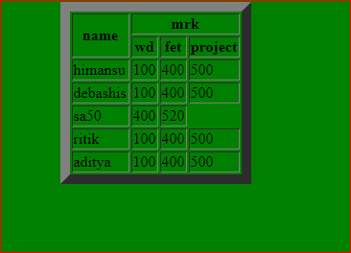

**2.**

<html>

<head>

<title>himansu</title>

</head>

<body bgcolor=red>

<table cellspacing=5 border=5>

<tr>

<th>name</th>

<th>rollno</th>

<th>branch</th>

</tr>

<tr>

<td>himansu</td>

<td>23</td>

<td>it</td>

</tr>

<tr>

<td>dhananjay</td>

<td>17</td>

<td>it</td>

</tr>

<tr>

<td>sovit</td>

<td>13</td>

<td>civil</td>

</tr>

<tr>

<td>lucky</td>

<td>16</td>

<td>civil</td>

</tr>

<tr>

<td>deba</td>

<td>19</td>

<td>civil</td>

</tr>

</body>

</html>

**Output:-**

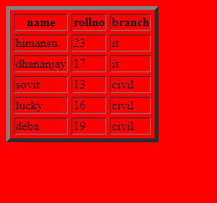

2.

<html>

<head>

<title>himansu</title>

</head>

<body bgcolor=yellow>

<table cellspacing=5 border=5>

<tr>

<th>slno</th>

<th>name</th>

<th>rollno</th>

<th>branch</th>

</tr>

<tr>

<td>1</td>

<td>himansu</td>

<td>f101</td>

<td>it</td>

</tr>

<tr>

<td>2</td>

<td>dhananjay</td>

<td>f102</td>

<td>it</td>

</tr>

<tr>

<td>3</td>

<td>sovit</td>

<td>f103</td>

<td>civil</td>

</tr>

<tr>

<td>4</td>

<td>lucky</td>

<td>f104</td>

<td>civil</td>

</tr>

<tr>

<td>5</td>

<td>deba</td>

<td>f105</td>

<td>civil</td>

</tr>

</body>

</html>

**OUTPUT:-**

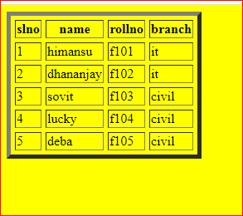

**<!-- A PROGRAM TO ILLUSTRATE TABLE TAG USING CELL SPACING-->**

<html>

<head>

<title>himansu</title>

</head>

<body bgcolor=mergenta>

<table cellspacing=5 border=5>

<tr>

<th colspan=4>cellspacing</th>

<tr>

<th>name</th>

<th>mark</th>

</tr>

<tr>

<td>himansu</td>

<td>570</td>

</tr>

<tr>

<td>dhananjay</td>

<td>370</td>

</tr>

<tr>

<td>sovit</td>

<td>410</td>

</tr>

<tr>

<td>lucky</td>

<Std>470</td>

</tr>

<tr>

<td>deba</td>

<td>300</td>

</tr>

</body>

</html>

**OUTPUT:-**

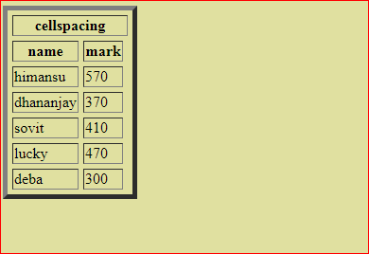

**HYPERLINK**

## HTML Links - Hyperlinks

HTML links are hyperlinks.

You can click on a link and jump to another document.

When you move the mouse over a link, the mouse arrow will turn into a little hand.

## Syntax

Hyperlinks are defined with the HTML <a> tag:

<a href="*url*">*link text*</a>

**<!-- A PROGRAM TO ILLUSTRATE HYPERLINK TAG -->**

1.

<html>

<head>

<title>hyperlink</title>

</head>

<body>

<center>

<img src="C:\Users\user\Desktop\sarita\logo.jpg" HEIGHT="150" WIDTH="150">

</center>

<center><h1<b>SKDAV</b></h1></center><br>

<a href="class.html">classroom </a><br>

<a href="coe.html">coe</a><br>

<a href="lib.html">library</a><br>

<a href="work.html">workshop </a><br>

</body>

</html>

CLASS.HTML

<html>

<head>

<title>class</title>

</head>

<body>

<center><h1><b>CLASSROOM</b></h1></center>

<img src="C:\Users\user\Desktop\sarita\classrum.jpg">

<p><mark>6th Sem IT </mark>branch classrum.</p>

</body>

</html>

COE.HTML

<html>

<head>

<title>coe</title>

</head>

<body>

<center><h1><b>COE</b></h1></center>

<img src="C:\Users\user\Desktop\sarita\coe.jpg">

<p><mark>skdav COE</mark>with number of pcs for staff and student.</p>

</body>

</html>

WORK.HTML

<html>

<head>

<title>workshop</title>

</head>

<body>

<center><h1><b>workshop</b></h1></center>

<img src="C:\Users\user\Desktop\sarita\workshop.jpg">

<p><mark>workshop of skdav</mark>with multiple machine with diffrent tools.</p>

</body>

</html>

LIB.HTML

<html>

<head>

<title>library</title>

</head>

<body>

<center><h1><b>library</b></h1></center>

<img src="C:\Users\user\Desktop\sarita\library.jpg">

<p><mark>library of skdav</mark>with number of pcs for student with books.</p>

</body>

</html>

 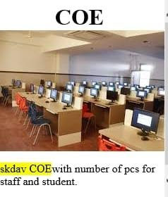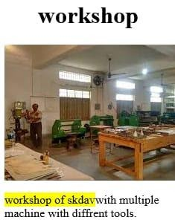 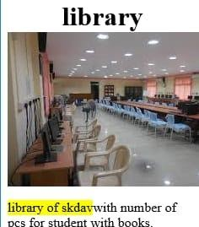

2.

<html>

<head>

<title>hyperlink</title>

</head>

<body>

<center><img src="C:\Users\user\Desktop\sarita\logo.jpg"></center>

<center><h1<b>SKDAV GOVT POLYTECHNIC</b></h1></center><br>

<a href="about us.html">ABOUT US</a>

<br><a href="mission.html">MISSION</a>

<br><a href="vision.html">VISION</a>

<br><a href="contact.html">CONTACT US</a>

</body>

</html>

Contact.html:

<html>

<head>

<title>contact</title>

<body bgcolor=lightslategray>

</head>

<p>S.K.D.A.V. GOVERNMENT POLYTECHNIC

BASANTI NAGAR ROURKELA-769012 Sundargarh, Odisha, India

Phone No: 0661 - 2420550(O) Fax : 0661 - 2420550

Email : principal_skdav@rediffmail.com</p>

</body>

</html>

Mission.html

<html>

<head>

<title>mission</title>

<body bgcolor=palevioletred>

</head>

<p>Engaging and enabling learners to face challenges of work and life</p>

</body>

</html>

Vision.html:

 <html>

<head>

<title>vission</title>

<body bgcolor=lightslategray>

</head>

<p>To Produce innovative and enterprising graduates</p>

</body>

</html>

About us.html:

<html>

<head>

<title>about us</title>

<body bgcolor=khaki>

</head>

<p>Let me define a leader. He must have vision and passion and not be afraid of any problem. Instead, he should know how to defeat it. Most importantly,

 he must work with integrity.

A.P.J. Abdul Kalam

With this believe & faith on my role model, We at SKDAV Government Polytechnic,

Rourkela work together to make our Institution one of the best among the institutions

 of the state imparting Diploma Education. We believe in all round development of the students.

 They are to be technically sound along with profound mental ability so as to face the challenges of life.

Here we give special emphasis on theoretical and experimental learning through a team of dedicated trainers.

 The academic activities concentrate on helping the trainee to gain an excellent theoretical knowledge base and the

 right skills to implement them. Our goal is to build up the skills & gifts of our students through varied rigorous learning

opportunities while working with them to overcome their challenges. Our staff works diligently to do whatever it takes

 for each and every student in our care to be successful. This Institution has established links with many renowned companies

 for industrial visits & campus interviews. There is also an ample of scope in co-curricular

 and extracurricular activities at this Institution, wherein the trainee are encouraged to showcase their talents.<br>

Wishing all the best for the future of SKDAV Government Polytechnic.

Rinata Das

Principal

</p>

</body>

 </html>

 

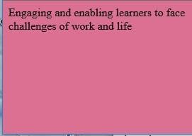 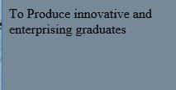



**FRAMESET**

**<!-- A PROGRAM TO ILLUSTRATE FRAMESET TAG -->**

<html>

<frameset rows=”40,50”>

<center>

<frame src=”skdav.html”</center>name=”my frame”>

<frameset cols=”50,50”>

<frame src=”frame11.html”name=f1>

<frame name=f2>

</frameset>

</frameset>

</html>

**Skdav.html;**

<html>

<head>

<title>hyper</title>

</head>

<body bgcolor=yellow>

<center><img src=”c:users/desktop/logo.jpg”></center>

<center>SKDAV GOVTPOLYTECHNIC</center>

</body></html>

**Frame11.html**

<html>

<head>

<title>hyper</title>

</head>

<body bgcolor=yellow>

<center><img src=”c:users/desktop/logo.jpg”></center>

<center>SKDAV GOVTPOLYTECHNIC</center>

<a href=”about us.html” target=”f2”><h4>about us</h4><br>

<a href=”mission.html” target=”f2”><h4>mission</h4><br>

<a href=”vision.html” target=”f2”><h4>vision</h4><br>

<a href=”contact.html” target=”f2”><h4>contact us</h4><br>

</body></html>

 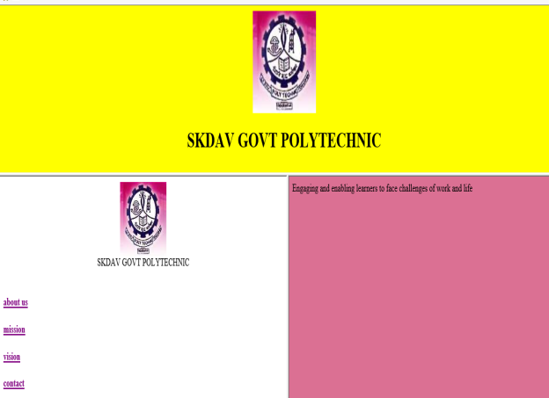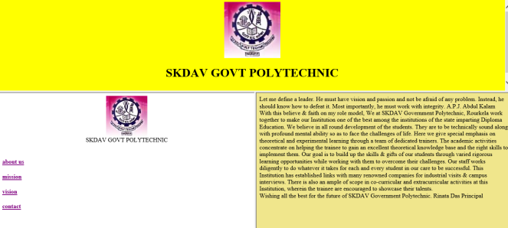 

2.

<html>

<frameset rows=”40,50”>

<center>

<frame src=”html1.html”</center>name=”my frame”>

<frameset cols=”50,50”>

<frame src=”frame22.html”name=f1>

<frame name=f2>

</frameset>

</frameset>

</html>

**HTML1.HTML**

<html>

<head>

<title>hyper</title>

</head>

<body bgcolor=yellow>

<center><img src=”c:users/desktop/logo.jpg”></center>

<center>HTML</center>

</body></html>

**FRAME22.HTML**

<html>

<head>

<title>hyper</title>

</head>

<body bgcolor=yellow>

<center><img src=”c:users/desktop/logo.jpg”></center>

<center>SKDAV GOVTPOLYTECHNIC</center>

<a href=”char.html” target=”f2”><h4>character</h4><br>

<a href=”dd.html” target=”f2”><h4>list</h4><br>

<a href=”sylaa.html” target=”f2”><h4>table</h4><br>

<a href=”text.html” target=”f2”><h4>text</h4><br>

</body></html>

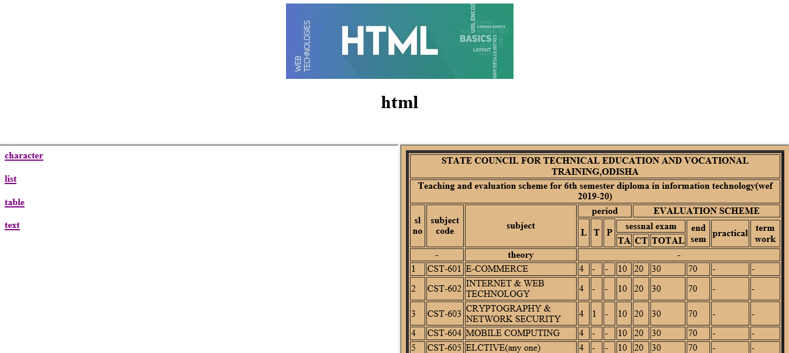

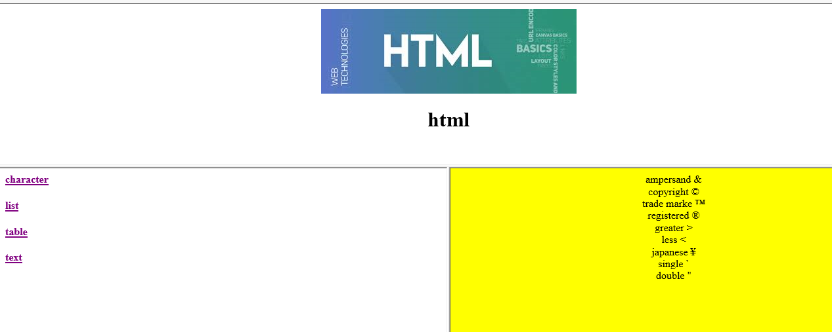

**FORM**

HTML Forms are required, when you want to collect some data from the site visitor. For example, during user registration you would like to collect information such as name, email address, credit card, etc.

A form will take input from the site visitor and then will post it to a back-end application such as CGI, ASP Script or PHP script etc. The back-end application will perform required processing on the passed data based on defined business logic inside the application.

There are various form elements available like text fields, textarea fields, drop-down menus, radio buttons, checkboxes, etc.

The HTML **<form>** tag is used to create an HTML form and it has following syntax −

<form action = "Script URL" method = "GET|POST">

form elements like input, textarea etc.

</form>

## Form Attributes

Apart from common attributes, following is a list of the most frequently used form attributes −

|  |  |
| --- | --- |
| **Sr.No** | **Attribute & Description** |
| 1 | **action**  Backend script ready to process your passed data. |
| 2 | **method**  Method to be used to upload data. The most frequently used are GET and POST methods. |
| 3 | **target**  Specify the target window or frame where the result of the script will be displayed. It takes values like _blank, _self, _parent etc. |
| 4 | **enctype**  You can use the enctype attribute to specify how the browser encodes the data before it sends it to the server. Possible values are −  **application/x-www-form-urlencoded** − This is the standard method most forms use in simple scenarios.  **mutlipart/form-data** − This is used when you want to upload binary data in the form of files like image, word file etc. |

## HTML Form Controls

## There are different types of form controls that you can use to collect data using HTML form −

* Text Input Controls
* Checkboxes Controls
* Radio Box Controls
* Select Box Controls
* File Select boxes
* Hidden Controls
* Clickable Buttons
* Submit and Reset Button

**<!-- A PROGRAM TO ILLUSTRATE FORMTAG -->**

1.

<html>

<head>

<title>form</title>

</head>

<body bgcolor=cornmilk>

<center><h3>APPLICATION FORM FOR ADMISSSION</h3>

<Form method=”post”action=”/cgi/generic”>

FIRST NAME:<input type=”text”name=”name”size=”20”/><p>

LAST NAME:<input type=”text”name=”name”size=”20”/><p>

Gender :<input type=”radio”name=”gender”value=”female”>female

<input type=”radio”name=”gender”value=”male”>male

Your mail Id:< Gender :<input type=”text”name=”Email”size=”20”/><p>

Hobbies : <input type=”checkbox”value=”reading”>reading

<input type=”checkbox”value=”reading”>writing

<input type=”checkbox”value=”reading”>singing

<input type=”checkbox”value=”reading”>dancing

<input type=”checkbox”value=”reading”>playing

Date of birth:<select name=”date”>

<option>1

<option>2

<option>3

<option>4

<option>5

<option>6

<option>7

<option>8

<option>9

<option>10

<option>11

<option>12

<option>13

<option>14

<option>15

<option>16

<option>17

<option>18

<option>19

<option>20

<option>21

<option>22

<option>23

<option>24

<option>25

<option>26

<option>27

<option>28

<option>29

<option>30

<option>31</select>

<select name=”month”>

<option>jan

<option>feb

<option>mar

<option>apr

<option>may

<option>june

<option>july

<option>aug

<option>sep

<option>oct

<option>nov

<option>dec</select>

<select name=”year”>

<option>1999

<option>2000

<option>2001

<option>2002

<option>2003

<option>2004

<option>2005

</select><br>

<input type=”submit”value=”submit”/>

<input type=”reset”value=”reset”/>

</form>

</center>

</body>

</html>

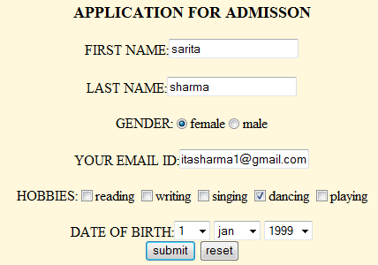

2.

<html>

<head>

<body bgcolor=orange>

<center><h1>ONLINE RESULT PUBLICATION</h1>

<h3>SKDAV GOVT POLYTECHNIC</h3>

<h2>MARK ENTRY FORM</h2>

<input type=”hidden”name=”name”value=nice@sify.com>

Regd no:<input type=”text”name=”regd no”size=30%<p><h1><br>

Branch:<select name=”branch”>

<option>IT

<option>ETC

<option>CIVIL

<option>ELEC

<option>MECH

</select><br>

<table border=5>

<tr>

<th>subject name</tr></th>

<tr>total marks</tr>

<th>secure mark</th>

</tr>

<tr>

<td>cgm</td>

<td>76</td>

<td>84</td>

</tr>

<tr>

<td>cndc</td>

<td>64</td>

<td>65</td>

</tr>

<tr>

<td>dbms</td>

<td>76</td>

<td>84</td>

</tr>

<tr>

<td>SE</td>

<td>76</td>

<td>84</td>

</tr>

<tr>

<td>evs</td>

<td>76</td>

<td>84</td>

</tr>

Total mark:<input type=”text”name=”total mark”size=10%<p>

Percentage :<input type=”text”name=”percentage”size=10%<p><br>

<input type=”submit”value=”submit”/>

</form></center></body>

</html>

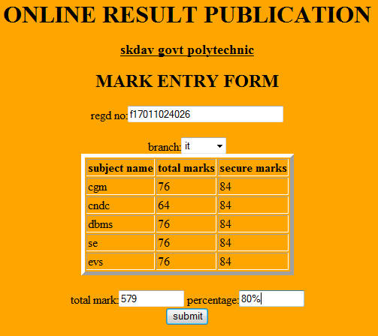

**JAVASCRIPT PROGRAMMING**

A **script** is a small piece of program that can add interactivity to your website. For example, a script could generate a pop-up alert box message, or provide a dropdown menu. This script could be written using JavaScript or VBScript.

You can write various small functions, called event handlers using any of the scripting language and then you can trigger those functions using HTML attributes.

Now-a-days, only **JavaScript** and associated frameworks are being used by most of the web developers, VBScript is not even supported by various major browsers.

You can keep JavaScript code in a separate file and then include it wherever it's needed, or you can define functionality inside HTML document itself.

1.WAP in javacsript to calculate area of rectangle.

<html>

<head>

<title>rectangle</title>

<script>

var x,y;

function area(f)

{

x=parseInt(f.a.value);

y=parseInt(f.b.value);

f.c.value=x*y;

}

</script>

</head>

<body>

<form>

<h1 align="center">AREA</h1>

<pre><center>

<br>enter the length:<input type=text name="a">

<br>enter the bredth:<input type=text name="b">

<br>area is:<input type=text name="c">

<br><input type=button value="area"onclick="area(this.form)">

</pre></center>

</form>

</body>

</html>

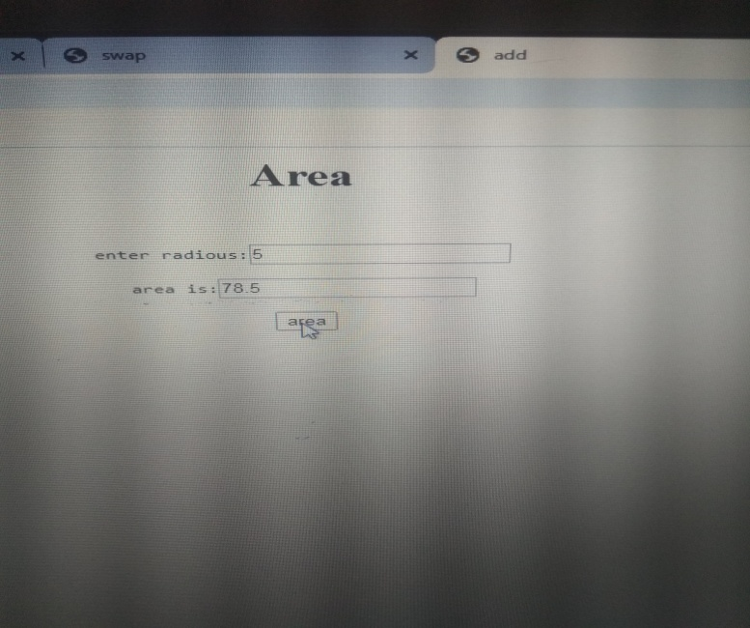

2.WAP in java script to calculate the simple interest.

<html>

<head>

<title>add</title>

<script>

var p,t,r;

function si(f)

{

p=parseInt(f.a.value);

t=parseInt(f.b.value);

r=parseInt(f.c.value);

f.d.value=p*t*r;

}

</script>

</head>

<body>

<form>

<h1 align="center">SIMPLE INTREST</h1>

<pre><center>

<br>enter the principl:<input type=text name="a">

<br>enter the time:<input type=text name="b">

<br>enter the rate:<input type=text name="c">

<br>simple interset is:<input type=text name="d">

<br><input type=button value="si"onclick="si(this.form)">

</pre></center>

</form>

</body>

</html>

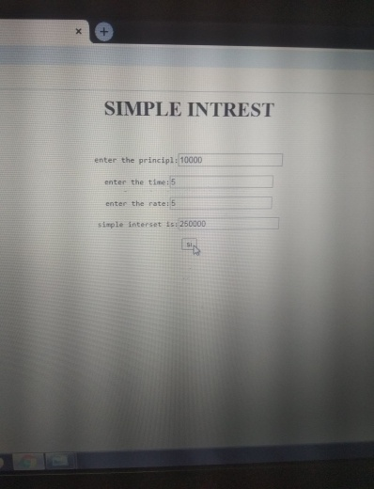

3.WAP in javascript to swap two nos.

<html>

<head>

<title>swap</title>

<script>

var x,y,z;

function swap(f)

{

x=parseInt(f.a.value);

y=parseInt(f.b.value);

z=x;

x=y;

y=z;

f.a.value=x;

f.b.value=y;

}

</script>

</head>

<body>

<form>

<h1 align="center">swap</h1>

<pre><center>

<br>enter the 1st no:<input type=text name="a">

<br>enter the 2nd no:<input type=text name="b">

<br><input type=button value="swap"onclick="swap(this.form)">

</pre></center>

</form>

</body>

</html>

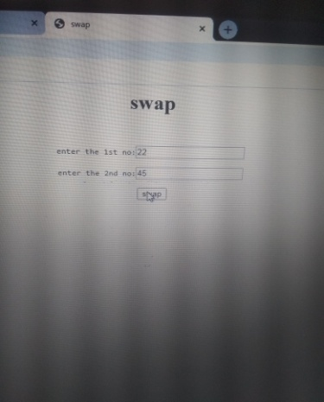

4.WAP in javascript to print the area of a circle.

<html>

<head>

<title>add</title>

<script>

var r;

function area(f)

{

r=parseInt(f.a.value);

f.b.value=3.14*r*r;

}

</script>

</head>

<body>

<form>

<h1 align="center">Area</h1>

<pre><center>

<br>enter radious:<input type=text name="a">

<br>area is:<input type=text name="b">

<br><input type=button value="area"onclick="area(this.form)">

</pre></center>

</form>

</body>

</html>

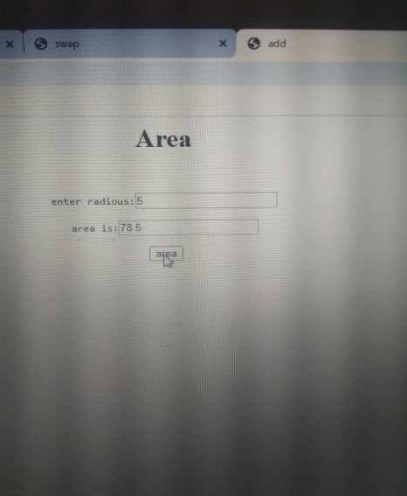

**IF PROGRAMMING**

5.WAP in java script to check the year is leap year or not.

<html>

<head>

<title>leap</title>

<script>

var year;

function leap(f)

{

year=parseInt(f.a.value);

if(year%4==0&&year%100!=0||year%400==0)

{

alert("leap year");

}

else

{

alert("not")

}}

</script>

</head>

<body>

<form>

<h1 align="center">YEAR</h1>

<pre><center>

<br>enter a year:<input type=text name="a">

<br><input type=button value="check"onclick="leap(this.form)">

</pre></center>

</form>

</body>

</html>

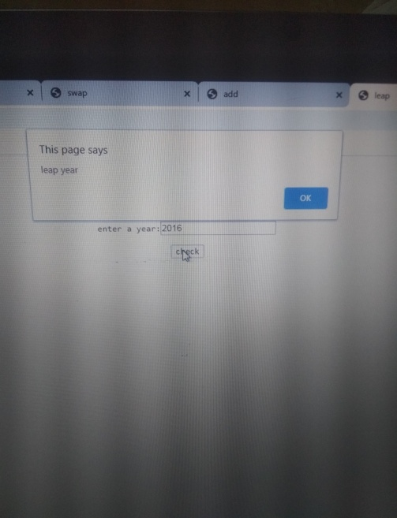

6.WAP in java script to check the no is even or odd.

<html>

<head>

<title>even</title>

<script>

var n;

function even(f)

{

n=parseInt(f.a.value);

if(n%2==0)

{

alert("even");

}

else

{

alert("odd")

}}

</script>

</head>

<body>

<form>

<h1 align="center">number</h1>

<pre><center>

<br>enter a number:<input type=text name="a">

<br><input type=button value="check"onclick="even(this.form)">

</pre></center>

</form>

</body>

</html>

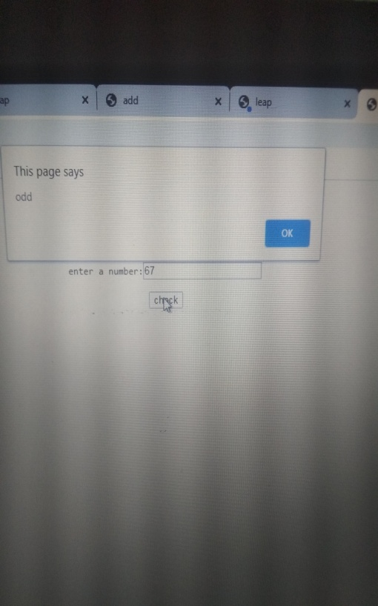

7.write a javascript to fpnd greatest among 3 nos.

<html>

<head>

<title>three</title>

<script>

var a,b,c;

function gr(f)

{

a=parseInt(f.x.value);

b=parseInt(f.y.value);

c=parseInt(f.z.value);

if(a>b && a>c)

{

alert("1st is greatest");

}

else

if(b>a && b>c)

{

alert("2nd is greatest");

}

else

if(c>a && c>b)

{

alert("3rd is greatest");

}}

</script>

</head>

<body>

<form>

<h1 align="center">number</h1>

<pre><center>

<br>enter 1st number:<input type=text name="x">

<br>enter 2nd number:<input type=text name="y">

<br>enter 3rd number:<input type=text name="z">

<br><input type=button value="check"onclick="gr(this.form)">

</pre></center>

</form>

</body>

</html>

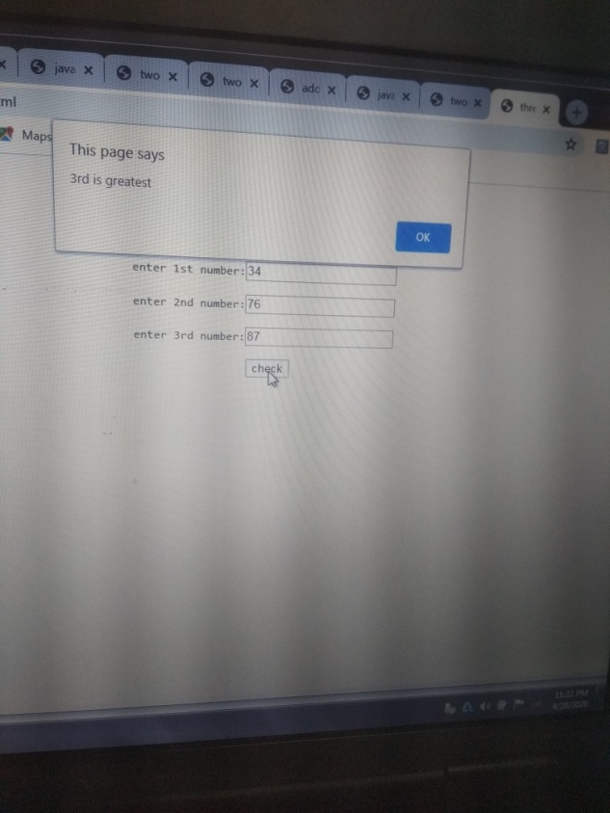

8.WAP in javascript to print 1 to10.

<html>

<head>

<title>two</title>

<script>

var n;

function fr(f)

{

for(n=1;n<=10;n++)

{

document.write(n +"<br>");

}}

</script>

</head>

<body>

<form>

</center>

<h1 align="center">display the number</h1>

<pre><br>

<br><input type=button value="display"onclick="fr(this.form)">

</pre></center>

</form>

</body>

</html>

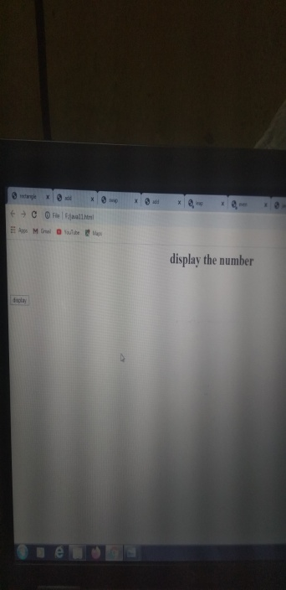 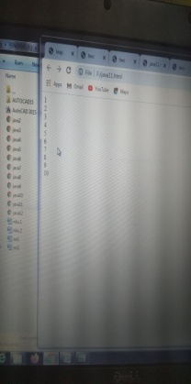

9.WAP in javascript for print 10 to 1.

<html>

<head>

<title>two</title>

<script>

var n;

function fr(f)

{

for(n=10;n>=1;n--)

{

document.write(n);

}}

</script>

</head>

<body>

<form>

</center>

<h1 align="center">display the number</h1>

<pre><br>

<br><input type=button value="display"onclick="fr(this.form)">

</pre></center>

</form>

</body>

</html>

 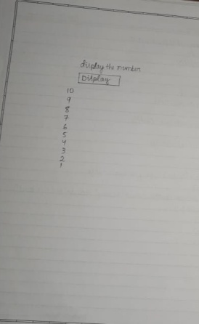

10. WAP in javascript to calculate the factorial of a no.

<html>

<head>

<title>two</title>

<script>

var a=0,b=1,c,n,i;

function fibo(f)

{

n=ParseInt(f.x.value);

document.write(a);

document.write(b);

for(i=1;i<=n;n++)

{

C=a+b;a-b;b=c;

}

document.write(c +”<br>);

}

}

</script>

</head>

<body>

<form>

</center>

<h1 align="center"> number</h1>

<pre><br>

Enter the number<input.type=text name=”x”><br>

<br><input type=button value="check"onclick="fibo(this.form)"><br>

</pre></center>

</form>

</body>

</html>

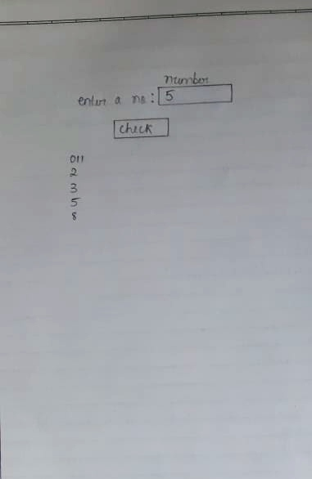

11.WAP IN javascript to print fibonaci series

<html>

<head>

<title>two</title>

<script>

var n,fact=1,i;

function fact(f)

{

n=ParseInt(f.a.value);

for(i=1;i<=n;n++)

{

Fact=fact*i;

}

document.write(fact);

}

}

</script>

</head>

<body>

<form>

</center>

<h1 align="center"> number</h1>

<pre><br>

Enter the number<input.type=text name=”a”><br>

<br><input type=button value="check"onclick="fac(this.form)"><br>

</pre></center>

</form>

</body>

</html>

